CIVIL LAW PAPER I · ISLAMABAD HIGH COURT · CIVIL JUDGE-CUM-MAGISTRATE EXAMINATION 2026
Topic 3 · The Law of Contract — General Principles
Contract Act 1872, sections 1 to 75 — formation, capacity, consent, consideration, void agreements, performance, discharge, quasi-contracts and remedies for breach
Knowledge Base — every concept in simple words, with rationale, cases, ratio decidendi and maxims

Prepared for: Ihtisham Ul Haq (Roll No. 999)
Paper: Civil Law-I — Monday, 26 October 2026, 2:00 PM to 5:00 PM (reporting 1:30 PM)
This volume: Topic 3 of 4 — Contract Act 1872, ss. 1–75 (general principles)
Companion volumes: Topic 1 — CPC Part I · Topic 2 — CPC Part II · Topic 4 — Specific contracts (indemnity, guarantee, bailment, pledge, agency) and Sale of Goods Act 1930
Text of the law used: Official text of the Contract Act 1872 as in force in Pakistan (pakistancode.gov.pk, updated February 2025)

Contents
How to use this knowledge base 4
What Topic 3 covers 4
How the exam asks contract questions 5
Chapter 1 · What a contract is — the essentials (ss. 2 and 10) 6
1.1 From proposal to contract — the ladder of s. 2 6
1.2 What agreements are contracts — s. 10 7
1.3 Kinds of contracts and agreements 8
Chapter 2 · Proposal and acceptance (ss. 2(a)–(b), 3 to 9) 10
2.1 Proposal (offer) 10
2.2 Invitation to treat — not an offer 10
2.3 Acceptance — s. 7, s. 8 11
2.4 Communication — s. 4 (when complete) 12
2.5 Revocation — ss. 5 and 6 13
Chapter 3 · Consideration and privity (ss. 2(d), 25) 15
3.1 Meaning 15
3.2 Essentials of consideration 15
3.3 Privity of contract 16
3.4 Agreements without consideration — s. 25 and its exceptions 16
Chapter 4 · Capacity to contract — minors and persons of unsound mind (ss. 11, 12, 68) 20
4.1 Who is competent — s. 11 20
4.2 Nature of a minor's agreement — void ab initio 20
4.3 The rules on minors — one by one 21
4.4 Persons of unsound mind — s. 12 23
4.5 Persons disqualified by law 24
Chapter 5 · Free consent (ss. 13 to 22) 25
5.1 Consent and free consent 25
5.2 Coercion — s. 15 26
5.3 Undue influence — ss. 16 and 19A 27
5.4 Fraud — s. 17 30
5.5 Misrepresentation — s. 18 31
5.6 Mistake — ss. 20, 21, 22 32
Chapter 6 · Lawful consideration and lawful object (ss. 23, 24) 36
6.1 Consideration and object — two different things 36
6.2 When are they unlawful — s. 23 36
6.3 The effect of illegality 38
6.4 Partial illegality — s. 24 and severability 39
Chapter 7 · Agreements expressly declared void (ss. 26 to 30C) 41
7.1 Restraint of marriage — s. 26 41
7.2 Restraint of trade — s. 27 41
7.3 Restraint of legal proceedings — s. 28 43
7.4 Uncertainty — s. 29 44
7.5 Wagering agreements — s. 30 44
7.6 Other void agreements 46
Chapter 8 · Contingent contracts (ss. 31 to 36) 48
8.1 Meaning — s. 31 48
8.2 Rules for enforcement 48
Chapter 9 · Performance of contracts (ss. 37 to 61) 50
9.1 The duty to perform — s. 37 50
9.2 Offer to perform (tender) — s. 38 50
9.3 Refusal to perform — s. 39 and anticipatory breach 50
9.4 Who must perform — ss. 40 to 45 51
9.5 Time and place — ss. 46 to 50 52
9.6 Reciprocal promises — ss. 51 to 58 52
9.7 Time as of the essence — s. 55 53
9.8 Appropriation of payments — ss. 59 to 61 54
Chapter 10 · Discharge — agreement, frustration and other modes (ss. 56, 62–67) 56
10.1 The ways a contract ends 56
10.2 Discharge by agreement — s. 62 56
10.3 Remission and accord and satisfaction — s. 63 57
10.4 Rescission of voidable contracts — ss. 64 and 66 57
10.5 Frustration and impossibility — s. 56 58
10.6 Restitution after a void agreement — s. 65 60
10.7 Promisee's neglect to give facilities — s. 67 61
Chapter 11 · Quasi-contracts — relations resembling contract (ss. 68 to 72) 62
11.1 The idea 62
11.2 The five cases 62
11.3 Quantum meruit — "as much as he has earned" 64
Chapter 12 · Breach of contract and remedies (ss. 73 to 75) 66
12.1 Kinds of breach 66
12.2 Compensation for breach — s. 73 66
12.3 Penalty and liquidated damages — s. 74 69
12.4 Compensation on rightful rescission — s. 75 71
Chapter 13 · Terms of a contract — intention and relative importance 72
13.1 Finding the intention of the parties 72
13.2 Express and implied terms 72
13.3 Conditions, warranties and innominate terms 72
13.4 Exemption (exclusion) clauses — a short note 75
Chapter 14 · Legal maxims for Topic 3 — at a glance 76
Chapter 15 · The great distinctions of Topic 3 78
Chapter 16 · Exam technique — contract problems 80
16.1 The five-step method for a contract problem 80
16.2 How to write the answer 80
16.3 A 3-hour plan (reminder) 81
Chapter 17 · Last-night revision sheet 82
zzTOCENDzz

How to use this knowledge base

What Topic 3 covers
The Contract Act 1872 is the foundation of commercial law in Pakistan. Its first 75 sections state the general principles that apply to every contract — a loan, a sale of land, a building contract, employment, a bank guarantee. Topic 4 will take the special contracts (indemnity, guarantee, bailment, pledge, agency) and the Sale of Goods Act 1930. This volume covers:
- the nature of a contract and its essentials (ss. 2, 10);
- proposal and acceptance, communication and revocation (ss. 3–9);
- consideration and privity, and agreements without consideration (ss. 2(d), 25);
- capacity — minors and persons of unsound mind (ss. 11–12, 68);
- free consent — coercion, undue influence, fraud, misrepresentation and mistake (ss. 13–22);
- lawful consideration and object (ss. 23–24);
- void agreements — restraint of marriage, trade and legal proceedings, uncertainty and wagers (ss. 26–30C);
- contingent contracts (ss. 31–36);
- performance — by whom, when, where; reciprocal promises; time as of the essence; appropriation of payments (ss. 37–61);
- discharge — novation, remission, rescission and frustration (ss. 56, 62–67);
- quasi-contracts (ss. 65, 68–72);
- remedies for breach — damages, penalty and liquidated damages (ss. 73–75); and
- terms of a contract — the intention of the parties and the relative importance of terms (conditions, warranties, innominate terms).
The pattern of every chapter is the same as in Topics 1 and 2: the idea in plain words, the law (quoted), ingredients, rationale, case studies with ratio decidendi, maxims, illustrations, exam tips and common mistakes, and a quick recap.
ISLAMABAD-SPECIFIC LAW · The Contract Act as it applies in Pakistan
The Contract Act is a federal law that "extends to the whole of Pakistan" (s. 1). A few Pakistani features differ from the Indian Act, on which many textbooks are based:
- Sections 30A–30C (inserted by Ordinance XLVII of 1960) make agreements collateral to wagering agreements void, bar suits for brokerage or commission on them, and deny credit to guardians and executors for such payments. In India, collateral agreements remain valid (Gherulal Parakh v. Mahadeodas Maiya, AIR 1959 SC 781).
- Section 74 carries illustrations (d)–(g) (added by Act VI of 1899) on increased interest and acceleration clauses.
- Section 27 has only the goodwill exception; the partnership exceptions were moved to the Partnership Act 1932.
- The chapters on sale of goods (ss. 76–123) and partnership (ss. 239–266) were repealed by the Sale of Goods Act 1930 and the Partnership Act 1932.
- Contracts are also tested against the Injunctions of Islam (Art. 227 of the Constitution); provisions involving riba (interest) have been the subject of Federal Shariat Court proceedings — a point to remember when discussing interest under s. 74.

How the exam asks contract questions
Paper | What it asked (Contract Act, general part)
KP High Court, Civil Law-I, 2026 (same syllabus as IHC) | Agreements by minors and persons of unsound mind; intention of parties and the relative importance of contractual terms (conditions, warranties, innominate terms)
Lahore High Court, Civil Law-I, 2023 | Exceptions to s. 25 (agreements without consideration) with illustrations; offer, acceptance, invitation to treat, revocation — are bids invited by advertisement offers?
Lahore High Court, Civil Law-I, 2022 | Agreement vs contract; void vs voidable; promise and reciprocal promises; mistake of fact; "All agreements are contracts" — discuss all aspects and essentials
Lahore High Court, Civil Law-I, 2017 | E-mail negotiations for the sale of a car (offer, counter-offer, acceptance, revocation); mother's guarantee signed under her son's persuasion (undue influence, misrepresentation, capacity)
Sindh High Court, Civil Law, 2022 | What agreements are contracts? Who is competent? Must contracts be in writing? or when is consent not free? with illustrations
LHC ASJ, Civil Law-I, 2020 | Difference between "consideration" and "object"; when are they lawful?

EXAM TIP · Use the illustrations in the Act
The Contract Act is full of statutory illustrations. They are part of the Act and are excellent authority. In the exam (with the bare Act in hand), quote the illustration that fits your facts — e.g., "This is exactly illustration (c) to s. 25." It shows mastery and saves time.

Chapter 1 · What a contract is — the essentials (ss. 2 and 10)

1.1 From proposal to contract — the ladder of s. 2
Section 2 builds the idea of a contract step by step:
"(a) When one person signifies to another his willingness to do or to abstain from doing anything, with a view to obtaining the assent of that other to such act or abstinence, he is said to make a proposal: (b) When the person to whom the proposal is made signifies his assent thereto, the proposal is said to be accepted. A proposal, when accepted, becomes a promise: (c) The person making the proposal is called the 'promisor', and the person accepting the proposal is called the 'promisee': (d) When, at the desire of the promisor, the promisee or any other person has done or abstained from doing, or does or abstains from doing, or promises to do or to abstain from doing, something, such act or abstinence or promise is called a consideration for the promise: (e) Every promise and every set of promises, forming the consideration for each other, is an agreement: (f) Promises which form the consideration or part of the consideration for each other are called reciprocal promises: (g) An agreement not enforceable by law is said to be void: (h) An agreement enforceable by law is a contract: (i) An agreement which is enforceable by law at the option of one or more of the parties thereto, but not at the option of the other or others, is a voidable contract: (j) A contract which ceases to be enforceable by law becomes void when it ceases to be enforceable."
So: proposal + acceptance = promise; promise + consideration = agreement; agreement + enforceability = contract.
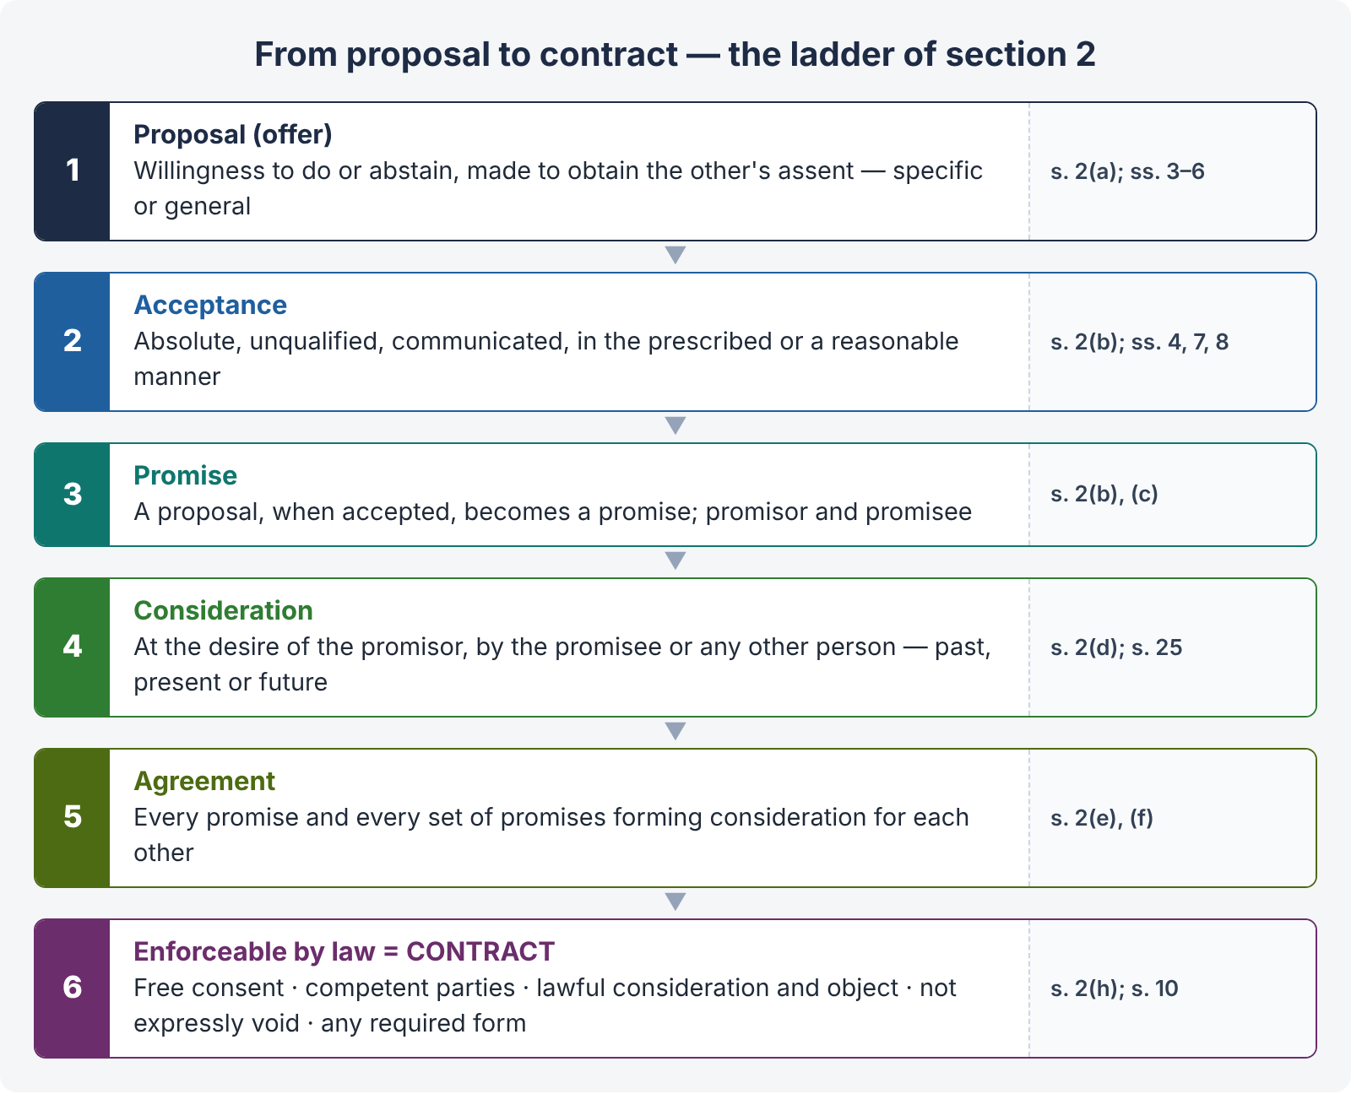
Figure 1 · From proposal to contract — the ladder of section 2
LEGAL MAXIM · Every contract is an agreement, but every agreement is not a contract
An agreement becomes a contract only when the law will enforce it. Social and domestic arrangements, agreements without consideration, agreements with unlawful objects, and agreements declared void are agreements — but not contracts.

1.2 What agreements are contracts — s. 10
"10. All agreements are contracts if they are made by the free consent of parties competent to contract, for a lawful consideration and with a lawful object, and are not hereby expressly declared to be void. Nothing herein contained shall affect any law in force in Pakistan, and not hereby expressly repealed, by which any contract is required to be made in writing or in the presence of witnesses, or any law relating to the registration of documents."

The essentials of a valid contract
- Offer and acceptance — there must be an agreement (s. 2(a)–(e)).
- Intention to create legal relations — implied in the words "enforceable by law".
- Lawful consideration (ss. 2(d), 23, 25).
- Capacity of parties (ss. 11–12).
- Free consent (ss. 13–22).
- Lawful object (ss. 23–24).
- Not expressly declared void (ss. 24–30, 56).
- Certainty of meaning (s. 29).
- Possibility of performance (s. 56).
- Formalities — writing, attestation or registration where another law requires them (s. 10, second para).

Intention to create legal relations
The Act does not say this in words, but it is implied by "enforceable by law". In commercial agreements the intention is presumed; in social and domestic arrangements the presumption is the other way.
CASE STUDY · Balfour v. Balfour ([1919] 2 KB 571)
Facts. A husband, going abroad for work, promised to pay his wife £30 a month. Later they separated and he stopped paying. She sued.
Held. The promise was not enforceable. Agreements between husband and wife in the ordinary course of domestic life are not usually intended to have legal consequences; "the small courts of this world" — family homes — are not to be governed by contract law.
Ratio. Where the parties did not intend legal consequences, there is no contract even if there is offer, acceptance and consideration. The intention is judged objectively from the nature of the relationship and the circumstances. (Contrast Merritt v. Merritt [1970] 1 WLR 1211, where spouses who had separated made a written agreement about the house — held binding.)

Must a contract be in writing?
No — as a general rule. A contract may be oral, written or implied from conduct (s. 9: "In so far as the proposal or acceptance of any promise is made in words, the promise is said to be express. In so far as such proposal or acceptance is made otherwise than in words, the promise is said to be implied."). But s. 10 preserves other laws that require writing or registration. For example:
- s. 25(1) and (3), Contract Act — a promise without consideration out of natural love and affection must be written and registered; a promise to pay a time-barred debt must be written and signed;
- Transfer of Property Act 1882 — sale of immovable property of Rs. 100 or more, mortgage, lease of immovable property from year to year must be by registered instrument (ss. 54, 59, 107);
- Registration Act 1908, s. 17 — compulsory registration of specified documents;
- Negotiable Instruments Act 1881 — bills, notes and cheques are in writing by definition;
- Arbitration Act 1940 — an arbitration agreement must be written;
- Qanun-e-Shahadat 1984, Art. 17 — instruments relating to financial obligations or future obligations "shall be attested by two men, or one man and two women", and other matters as the law requires (Art. 17(2)(a)) — an important Pakistani rule of evidence and form for loan documents.
ILLUSTRATION · Oral contract
Naeem orally agrees to paint Hira's house in F-8 for Rs. 150,000; he paints it, and she refuses to pay. The contract is valid though oral; Naeem must prove it by evidence. (If Hira's promise were an agreement to sell her house, writing and registration would be needed for the transfer, though an oral agreement to sell can be specifically enforced if proved.)

1.3 Kinds of contracts and agreements
Kind | Meaning and example
Valid contract | All essentials present — enforceable.
Void agreement (s. 2(g)) | Not enforceable from the start — e.g., agreement with a minor (Mohori Bibee), agreement without consideration (s. 25), wager (s. 30).
Contract that becomes void (s. 2(j)) | Valid when made, but later ceases to be enforceable — e.g., frustration (s. 56), contingent event becomes impossible (s. 32).
Voidable contract (s. 2(i)) | Enforceable at the option of one party only — consent caused by coercion, undue influence, fraud or misrepresentation (ss. 19, 19A); or failure to perform at the essential time (s. 55).
Illegal agreement | Object or consideration forbidden by law, immoral or opposed to public policy (s. 23) — void, and collateral transactions are also tainted.
Unenforceable contract | Valid, but cannot be enforced for some technical reason — e.g., not stamped / registered when required, or time-barred (the right remains; the remedy is barred).
Express / implied | Made in words / inferred from conduct (s. 9) — e.g., boarding a bus implies a promise to pay the fare.
Executed / executory | Fully performed / still to be performed (one or both sides).
Unilateral / bilateral | Promise for an act (e.g., reward for finding a lost dog) / promise for a promise (most commercial contracts).
Quasi-contract | Not a contract at all; an obligation imposed by law to prevent unjust enrichment (ss. 68–72).
E-contract | Made by electronic means (e-mail, website "click-wrap"). The Electronic Transactions Ordinance 2002 gives legal recognition to electronic documents, communications and signatures, so the Contract Act's rules on offer, acceptance and communication apply to them.

Point | Void agreement | Voidable contract
Validity at start | Never enforceable | Valid until avoided
Who can enforce | Nobody | The party with the option; the other is bound until avoidance
Cause | Absence of an essential (capacity, consideration, lawful object) or express declaration | Defect in consent (coercion, undue influence, fraud, misrepresentation) or s. 55 breach
Third parties | Get no rights through it | A bona fide third party who acquires rights before avoidance is protected
Restitution | s. 65 — when discovered to be void | s. 64 — the party rescinding restores benefits

QUICK RECAP · Chapter 1 in six lines
- Proposal + acceptance = promise; promise + consideration = agreement; enforceable agreement = contract (s. 2).
- s. 10: free consent + competent parties + lawful consideration + lawful object + not declared void.
- Intention to create legal relations — presumed in commerce, not in domestic matters (Balfour v. Balfour).
- Writing not generally required (s. 9: express / implied), but other laws may require writing, attestation or registration (s. 10 para 2; Art. 17 QSO; TPA; Registration Act).
- Void vs voidable vs illegal vs unenforceable — know the differences.
- E-contracts recognised (Electronic Transactions Ordinance 2002).

Chapter 2 · Proposal and acceptance (ss. 2(a)–(b), 3 to 9)

2.1 Proposal (offer)
A proposal is a definite expression of willingness to be bound on certain terms, made "with a view to obtaining the assent" of the other (s. 2(a)). It may be:
- specific — to a particular person; or
- general — to the world at large; anyone who performs the conditions accepts it (s. 8).
CASE STUDY · Carlill v. Carbolic Smoke Ball Co. ([1893] 1 QB 256)
Facts. The company advertised that it would pay £100 to anyone who used its smoke ball three times daily for two weeks and still caught influenza, and deposited £1,000 in a bank to show sincerity. Mrs Carlill used it as directed and caught influenza.
Held. The advertisement was a general offer to the world, not a mere puff (the deposit showed serious intent). It was accepted by performing the conditions, and notice of acceptance was impliedly dispensed with. She was entitled to £100.
Ratio. A general offer can be accepted by anyone who performs its conditions; performance is acceptance (s. 8 of our Act says the same).

Knowledge of the offer is essential
CASE STUDY · Lalman Shukla v. Gauri Dutt ((1913) 11 ALJ 489)
Facts. The defendant's nephew absconded. The plaintiff, his servant, was sent to search for him. After he left, the defendant announced a reward for finding the boy. The plaintiff found him without knowing of the reward, and later claimed it.
Held. No contract: a person cannot accept an offer of which he has no knowledge. Acceptance means assent to the proposal, which is impossible without knowing it.

Cross offers
Identical offers made by two parties to each other in ignorance of each other's offer do not create a contract, because neither is an acceptance of the other.

2.2 Invitation to treat — not an offer
An invitation to treat (or "invitation to offer") is a statement inviting others to make offers. Responding to it makes an offer, which the inviter may accept or reject. Common examples:
- Goods displayed in a shop with price tags.
- Advertisements of goods for sale, catalogues and price lists.
- Auction advertisements; at the auction, the bid is the offer and the fall of the hammer the acceptance.
- Tender notices — inviting bids is an invitation; each bid (tender) is an offer; the authority may accept the best or none.
- Prospectus inviting applications for shares.
- Quotation of price in reply to an inquiry.
CASE STUDY · Pharmaceutical Society of Great Britain v. Boots Cash Chemists ([1953] 1 QB 401)
Held. In a self-service shop, the display of goods with prices is an invitation to treat. The customer makes the offer at the cash desk, and the shop accepts it there (where a registered pharmacist supervised the sale). Otherwise a customer who picked up an item could not change his mind, and the shop could not refuse a sale.

CASE STUDY · Harvey v. Facey ([1893] AC 552, Privy Council)
Facts. H telegraphed: "Will you sell us Bumper Hall Pen? Telegraph lowest cash price." F replied: "Lowest price for Bumper Hall Pen £900." H replied: "We agree to buy … for £900."
Held. No contract. F's reply only answered the question about price; it was not an offer to sell. H's last telegram was an offer, which F never accepted.

CASE STUDY · Spencer v. Harding ((1870) LR 5 CP 561)
Held. A circular inviting tenders for the purchase of stock was not an offer to sell to the highest bidder; it was an invitation to make offers. No contract arose merely because the plaintiff's tender was the highest. (Contrast an express promise to accept the highest or lowest tender, which may itself be an offer.)

ILLUSTRATION · Tenders and bids in Pakistan (LHC 2023 question)
The Capital Development Authority advertises: "Sealed bids are invited for the construction of a community centre in I-10." This is an invitation to treat. Each contractor's bid is an offer. The CDA may accept any bid or reject all (subject to the Public Procurement Rules 2004 under the PPRA Ordinance 2002, which require transparency and reasons, and allow rejection of all bids before acceptance). Once the CDA communicates acceptance (a letter of acceptance), a contract is formed. A bidder may withdraw his bid before acceptance (s. 5), unless he has given a separate binding promise (e.g., a bid security forfeited under the tender conditions).

2.3 Acceptance — s. 7, s. 8
"7. In order to convert a proposal into a promise, the acceptance must— (1) be absolute and unqualified; (2) be expressed in some usual and reasonable manner, unless the proposal prescribes the manner in which it is to be accepted. If the proposal prescribes a manner in which it is to be accepted, and the acceptance is not made in such manner, the proposer may, within a reasonable time after the acceptance is communicated to him, insist that his proposal shall be accepted in the prescribed manner, and not otherwise; but if he fails to do so, he accepts the acceptance."
"8. Performance of the conditions of a proposal, or the acceptance of any consideration for a reciprocal promise which may be offered with a proposal, is an acceptance of the proposal."

Rules of acceptance
- Absolute and unqualified — a conditional or varied acceptance is a counter-offer, which destroys the original offer.
- Communicated to the proposer (s. 3) — mental acceptance is not enough; silence is not acceptance unless the parties have agreed otherwise or conduct shows assent.
- By the offeree (or his authorised agent) — a third person cannot accept.
- In the prescribed or a usual and reasonable manner (s. 7(2)).
- While the offer is alive — before lapse or revocation (s. 6).
- With knowledge of the offer (Lalman Shukla).
CASE STUDY · Hyde v. Wrench ((1840) 3 Beav 334)
Facts. W offered to sell his farm for £1,000. H replied offering £950. W refused. H then said he would pay £1,000. W refused.
Held. H's offer of £950 was a counter-offer which rejected and killed the original offer. H could not later revive it by "accepting" £1,000. (A mere inquiry — "Would you accept payment in two instalments?" — is not a counter-offer.)

CASE STUDY · Felthouse v. Bindley ((1862) 11 CBNS 869)
Facts. An uncle wrote to his nephew: "If I hear no more about him, I consider the horse mine at £30 15s." The nephew did not reply, though he intended to sell.
Held. No contract. The offeror cannot impose silence on the offeree as acceptance. Acceptance must be communicated.

2.4 Communication — s. 4 (when complete)
"4. The communication of a proposal is complete when it comes to the knowledge of the person to whom it is made. The communication of an acceptance is complete,— as against the proposer, when it is put in a course of transmission to him, so as to be out of the power of the acceptor; as against the acceptor, when it comes to the knowledge of the proposer. The communication of a revocation is complete,— as against the person who makes it, when it is put into a course of transmission to the person to whom it is made, so as to be out of the power of the person who makes it; as against the person to whom it is made, when it comes to his knowledge."
Communication of | Complete as against the sender | Complete as against the receiver
Proposal | — | When it comes to the knowledge of the offeree
Acceptance | (Proposer is bound) when put in course of transmission — e.g., posted | (Acceptor is bound) when it comes to the knowledge of the proposer
Revocation | When put in course of transmission | When it comes to the knowledge of the other

So, under the postal rule, the proposer is bound as soon as the letter of acceptance is posted; the acceptor is bound only when it reaches the proposer. In between, the acceptor can still revoke his acceptance by a faster means (s. 5).

Instantaneous communication — telephone, e-mail, chat
CASE STUDY · Entores Ltd. v. Miles Far East Corporation ([1955] 2 QB 327)
Held. For instantaneous communications (telephone, telex), the postal rule does not apply. The contract is complete only when the acceptance is received by the offeror, and is made at the place where the acceptance is received.

CASE STUDY · Bhagwandas Goverdhandas Kedia v. Girdharilal Parshottamdas (AIR 1966 SC 543)
Held. In a contract made over the telephone, the contract is complete where the acceptance is heard by the proposer, because under s. 4 the communication of acceptance is complete as against the proposer when it comes to his knowledge in instantaneous communication. The court at that place has jurisdiction (cause of action — s. 20 CPC).

E-mail and messages: courts generally treat them like instantaneous communications where delivery is immediate, so the acceptance is effective when it reaches the offeror's system / is capable of being read. The Electronic Transactions Ordinance 2002 recognises electronic communications and contains rules on their attribution and time of dispatch and receipt. In an exam problem, state the s. 4 rule, note the Entores / Bhagwandas line for instantaneous media, and reach a reasoned conclusion.

2.5 Revocation — ss. 5 and 6
"5. A proposal may be revoked at any time before the communication of its acceptance is complete as against the proposer, but not afterwards. An acceptance may be revoked at any time before the communication of the acceptance is complete as against the acceptor, but not afterwards."
Illustration (s. 5): A proposes by post to sell his house to B; B accepts by a letter sent by post. A may revoke his proposal at any time before or at the moment when B posts his acceptance, but not afterwards. B may revoke his acceptance at any time before or at the moment when his letter reaches A, but not afterwards.
"6. A proposal is revoked— (1) by the communication of notice of revocation by the proposer to the other party; (2) by the lapse of the time prescribed in such proposal for its acceptance, or, if no time is so prescribed, by the lapse of a reasonable time, without communication of the acceptance; (3) by the failure of the acceptor to fulfil a condition precedent to acceptance; or (4) by the death or insanity of the proposer, if the fact of his death or insanity comes to the knowledge of the acceptor before acceptance."
Also: an offer lapses on rejection or counter-offer (Hyde v. Wrench). A promise to keep an offer open is not binding without consideration (an "option" for which consideration is paid is binding).
ILLUSTRATION · The LHC 2017 car problem — the method
Farooq e-mails: "I will give you Rs. 1,500,000 for the car." (offer). Javaid replies: "Interesting suggestion. Would you go to Rs. 1,800,000?" — this is a counter-offer (or at least a new proposal) which rejects Farooq's offer (Hyde v. Wrench). Farooq replies: "Yes. Consider it sold at Rs. 1,800,000. No need to reply. I will collect it later in the week." This is an acceptance of Javaid's counter-proposal — absolute and unqualified, communicated by e-mail. Once it reached Javaid, a contract was formed (Entores; s. 4). Javaid's later sale to another person was a breach; when that deal fell through, Javaid could still demand performance — but whether Farooq is bound depends on whether Javaid had repudiated (anticipatory breach accepted by Farooq) — see the full model answer in the Q&A volume.

QUICK RECAP · Chapter 2 in eight lines
- Proposal = willingness to do / abstain, seeking assent (s. 2(a)); specific or general (Carlill); knowledge required (Lalman Shukla); cross offers make no contract.
- Invitation to treat: displays (Boots), price quotations (Harvey v. Facey), tenders (Spencer v. Harding), auction notices, prospectus.
- Acceptance: absolute and unqualified; counter-offer kills offer (Hyde v. Wrench); silence is not acceptance (Felthouse); prescribed / reasonable manner (s. 7); performance = acceptance (s. 8).
- s. 4: proposal complete on knowledge; acceptance binds proposer on posting, acceptor on receipt; revocation likewise.
- Instantaneous media: complete where acceptance is received / heard (Entores; Bhagwandas Kedia); e-contracts recognised (ETO 2002).
- s. 5: revoke proposal before acceptance is posted; revoke acceptance before it reaches proposer.
- s. 6: notice; lapse of time; failure of condition precedent; death / insanity known before acceptance.
- Tenders in Pakistan: bid = offer; letter of acceptance = acceptance; procurement rules regulate rejection.

Chapter 3 · Consideration and privity (ss. 2(d), 25)

3.1 Meaning
"2(d) When, at the desire of the promisor, the promisee or any other person has done or abstained from doing, or does or abstains from doing, or promises to do or to abstain from doing, something, such act or abstinence or promise is called a consideration for the promise."
In simple words, consideration is the price of the promise — "something in return" (quid pro quo). Without it, an agreement is generally void (s. 25).
LEGAL MAXIM · Ex nudo pacto non oritur actio — no action arises from a bare promise
A promise without consideration is a "nude pact" (gratuitous promise) and cannot be sued upon, except in the cases listed in s. 25.

LEGAL MAXIM · Quid pro quo — something for something
Each party gives something in exchange for what he receives. This is the core idea of consideration.

3.2 Essentials of consideration
- At the desire of the promisor — an act done at the desire of a third party, or voluntarily, is not consideration.
- By the promisee or any other person — in Pakistan (unlike England), consideration may move from a third person.
- Past, present or future — "has done … does … promises to do".
- Real, not illusory — must have some value in law (it need not be adequate — s. 25 Expl. 2).
- Not something the promisor is already legally bound to do — performing an existing legal duty (e.g., a public servant's official duty) is generally not consideration.
- Lawful (s. 23).
CASE STUDY · Durga Prasad v. Baldeo ((1880) ILR 3 All 221)
Facts. At the Collector's desire, the plaintiff built shops in a bazaar. The defendant, who occupied a shop, later promised to pay the plaintiff a commission on articles sold, in consideration of the plaintiff's expenditure.
Held. The promise was void for want of consideration, because the construction was done at the desire of the Collector, not of the promisor (the defendant).

CASE STUDY · Chinnaya v. Ramayya ((1882) ILR 4 Mad 137)
Facts. An old woman gifted her estate to her daughter on condition that the daughter would pay an annuity to the old woman's brother (the plaintiff). The daughter promised the brother to pay it, but did not.
Held. The brother could sue. Consideration moved from a third person (the mother), which is enough under s. 2(d) ("the promisee or any other person"); and the promise was made directly to the brother.

Past consideration — Pakistan vs England
Under s. 2(d) ("has done"), past consideration is good if the past act was done at the desire of the promisor. In English law past consideration is generally "no consideration". In addition, s. 25(2) makes enforceable a promise to compensate a person who voluntarily did something for the promisor.

Adequacy
"An agreement to which the consent of the promisor is freely given is not void merely because the consideration is inadequate; but the inadequacy of the consideration may be taken into account by the Court in determining the question whether the consent of the promisor was freely given" (s. 25 Expl. 2). Illustrations (f) and (g): a horse worth Rs. 1,000 sold for Rs. 10 — valid if consent was free; inadequacy is evidence on the question of free consent.

3.3 Privity of contract
Privity of contract means that only a party to a contract can sue on it; a stranger to the contract cannot, even if the contract was made for his benefit.
CASE STUDY · Dunlop Pneumatic Tyre Co. v. Selfridge & Co. ([1915] AC 847)
Held. Only a person who is a party to a contract can sue on it; and in English law consideration must move from the promisee. Dunlop, not being a party to the resale agreement between the dealer and Selfridge, could not enforce Selfridge's promise not to sell below list price. (Earlier: Tweddle v. Atkinson, (1861) 1 B & S 393.)

Privity in Pakistan — distinguish two rules
- Privity of consideration — not required: consideration may move from a third person (s. 2(d); Chinnaya).
- Privity of contract — generally followed: a stranger to the contract cannot sue (the Privy Council so held in Jamna Das v. Ram Autar, (1911) 39 IA 7, and Pakistani courts follow it).

Exceptions — when a stranger can sue
- Trust or charge — a beneficiary under a trust or a charge created by the contract (e.g., a provision for maintenance of a widow charged on property).
- Family settlements — members for whose benefit a family arrangement is made.
- Acknowledgment / estoppel — where the promisor acknowledges the third party's right (e.g., A pays B money for C; B acknowledges to C that he holds it for C).
- Covenants running with land — a purchaser of land with notice of a covenant is bound by it.
- Agency — the principal can sue on a contract made by his agent.
- Assignment — an assignee of contractual rights (e.g., of a debt) can sue.

3.4 Agreements without consideration — s. 25 and its exceptions
"25. An agreement made without consideration is void, unless— (1) it is expressed in writing and registered under the law for the time being in force for the registration of documents, and is made on account of natural love and affection between parties standing in a near relation to each other; or unless (2) it is a promise to compensate, wholly or in part, a person who has already voluntarily done something for the promisor, or something which the promisor was legally compellable to do; or unless (3) it is a promise, made in writing and signed by the person to be charged therewith, or by his agent generally or specially authorized in that behalf, to pay wholly or in part a debt of which the creditor might have enforced payment but for the law for the limitation of suits. In any of these cases, such an agreement is a contract. Explanation 1.— Nothing in this section shall affect the validity, as between the donor and donee, of any gift actually made. Explanation 2.— An agreement to which the consent of the promisor is freely given is not void merely because the consideration is inadequate …"
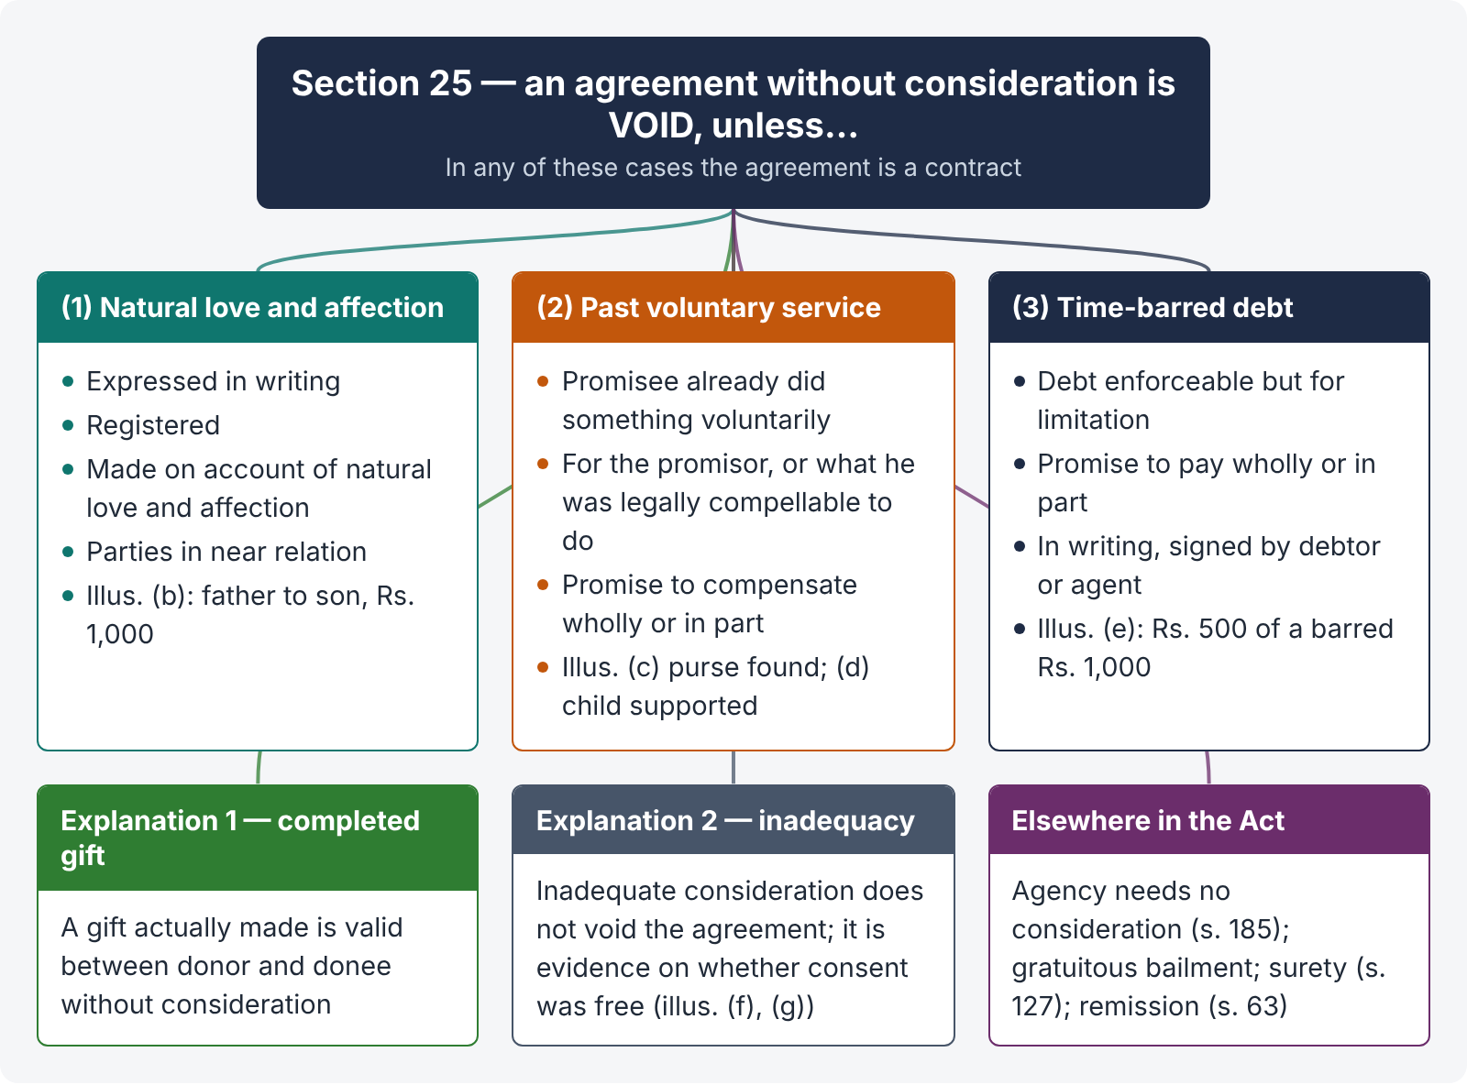
Figure 2 · Section 25 — the rule and its exceptions

Exception 1 — natural love and affection (s. 25(1))
Conditions: (a) in writing; (b) registered; (c) made on account of natural love and affection; (d) between parties in near relation. Illustration (b): A, for natural love and affection, promises to give his son B Rs. 1,000, puts it in writing and registers it — a contract. (Whether "near relation" and "love and affection" exist is a question of fact; a registered promise made in the context of a family quarrel may show no love and affection.)

Exception 2 — compensation for past voluntary service (s. 25(2))
Conditions: (a) the promisee did something voluntarily (not at the promisor's request — otherwise it would be ordinary past consideration); (b) for the promisor, or something the promisor was legally compellable to do; (c) the promisor was in existence and capable of contracting when the act was done; (d) the promise is to compensate wholly or in part. Illustrations (c) and (d): A finds B's purse and gives it to him; B promises A Rs. 50 — a contract. A supports B's infant son; B promises to pay A's expenses — a contract.

Exception 3 — time-barred debt (s. 25(3))
Conditions: (a) a debt which the creditor could have enforced but for limitation; (b) a promise to pay it wholly or in part; (c) in writing and signed by the debtor or his authorised agent. Illustration (e): A owes B Rs. 1,000, time-barred; A signs a written promise to pay Rs. 500 — a contract for Rs. 500.
COMMON MISTAKE · s. 25(3) vs s. 19 Limitation Act
- s. 19, Limitation Act: an acknowledgment in writing signed before the limitation period expires gives a fresh period of limitation for the existing debt.
- s. 25(3), Contract Act: a promise to pay a debt already time-barred creates a new contract; the suit is on the new promise.
An acknowledgment after expiry does not revive limitation under s. 19 — but if it contains an express promise to pay in writing and signed, it may be enforceable under s. 25(3).

Other exceptions
- Gift actually made (Expl. 1) — a completed gift needs no consideration; only a promise to give is void.
- Agency — "No consideration is necessary to create an agency" (s. 185).
- Bailment — gratuitous bailment is valid (ss. 148, 160).
- Guarantee — anything done or promise made for the benefit of the principal debtor is sufficient consideration to the surety (s. 127).
- Remission of performance — s. 63 allows a promisee to accept less, or any satisfaction, without fresh consideration (see Chapter 10).

Charitable subscriptions
CASE STUDY · Kedarnath Bhattacharji v. Gorie Mahomed ((1886) ILR 14 Cal 64)
Facts. The defendant subscribed Rs. 100 for building a town hall. On the strength of such subscriptions, the plaintiff (a commissioner) entered into a contract with a builder.
Held. The promise was enforceable: on the faith of it, the plaintiff incurred a liability at the promisor's (implied) desire; that was consideration. (Contrast Abdul Aziz v. Masum Ali, (1914) ILR 36 All 268: a promise to subscribe to rebuild a mosque was not enforceable, because nothing had been done on the faith of it — no consideration.)

QUICK RECAP · Chapter 3 in seven lines
- Consideration: at the desire of the promisor; from the promisee or any other person; past, present or future; real; not an existing legal duty; lawful (s. 2(d)).
- Durga Prasad (desire of promisor); Chinnaya (third-party consideration).
- Inadequacy does not void a contract but bears on free consent (s. 25 Expl. 2).
- Privity of contract: only parties sue (Dunlop; Jamna Das); exceptions — trust / charge, family settlement, acknowledgment / estoppel, covenant with land, agency, assignment.
- s. 25 exceptions: (1) written + registered + natural love and affection + near relation; (2) compensation for past voluntary service; (3) written, signed promise to pay a time-barred debt; plus completed gifts.
- Other no-consideration rules: agency (s. 185), gratuitous bailment, surety (s. 127), remission (s. 63).
- Charitable subscriptions enforceable only if the promisee acted on them (Kedarnath vs Abdul Aziz).

Chapter 4 · Capacity to contract — minors and persons of unsound mind (ss. 11, 12, 68)

4.1 Who is competent — s. 11
"11. Every person is competent to contract who is of the age of majority according to the law to which he is subject, and who is of sound mind, and is not disqualified from contracting by any law to which he is subject."
So three classes of persons are not competent:
- minors;
- persons of unsound mind (at the time of contracting — s. 12); and
- persons disqualified by law.
Rationale. The law of contract assumes that each party can understand his own interest and bargain for it. A child or a person who cannot understand the transaction is easily exploited, so the law protects him by refusing to hold him to his promises — even at the cost of the other party.

Age of majority in Pakistan
Under the Majority Act 1875, s. 3, a person attains majority on completing 18 years. The exception: where a guardian of the person or property has been appointed by a court (under the Guardians and Wards Act 1890) or the property is under a Court of Wards, majority comes at 21 years. The Majority Act does not govern marriage, dower, divorce, adoption and religion (s. 2) — those follow personal law.

4.2 Nature of a minor's agreement — void ab initio
The Act says that a minor is "not competent"; it does not say what happens to his agreement. The Privy Council supplied the answer.
CASE STUDY · Mohori Bibee v. Dharmodas Ghose ((1903) ILR 30 Cal 539, Privy Council)
Facts. Dharmodas, a minor, mortgaged his house to a money-lender, Brahmo Dutt, to secure a loan of Rs. 20,000, of which about Rs. 8,000 was actually advanced. The lender's attorney knew that Dharmodas was a minor. Dharmodas (through his mother as next friend) sued to have the mortgage declared void and cancelled. The lender (later his widow, Mohori Bibee) asked for repayment of the money advanced.
Held.
- A minor's agreement is void ab initio (absolutely void), not merely voidable. Sections 10 and 11 make competence an essential of a contract; an agreement by an incompetent person is therefore no contract at all.
- The lender could not recover the money under s. 64 (restoration on rescission of a voidable contract) or s. 65 (agreement discovered to be void), because those sections assume a contract between competent parties.
- Relief under s. 41, Specific Relief Act (compensation on cancellation) is discretionary; it was refused because the lender knew of the minority.
Ratio decidendi. An agreement with a minor is void from the beginning; it cannot be enforced against him, and a person who deals with a minor does so at his own risk.

LEGAL MAXIM · Minor's protection — "the law protects the minor even against himself"
The policy is to shield the minor from his own immaturity. Therefore the protection cannot be taken away by the minor's own act — not even by his lie about his age.

4.3 The rules on minors — one by one

Rule 1 — No ratification on majority
Because the agreement is void, there is nothing to ratify. A person who, on attaining majority, "ratifies" a loan taken during minority is not bound by the old agreement. If he makes a fresh promise for a fresh consideration, that new contract binds him. (The past advance is not good consideration for the new promise, because it was not given at the desire of a competent promisor.)

Rule 2 — No estoppel against a minor
Even if the minor falsely represented himself to be a major, he is not estopped from pleading minority. Estoppel (Art. 114, Qanun-e-Shahadat 1984) is a rule of evidence and cannot create a contract that the law of contract says cannot exist (Sadiq Ali Khan v. Jai Kishori, AIR 1928 PC 152).

Rule 3 — Restitution: the minor may be made to restore benefits (equity)
If the minor obtained property or money by fraud, the court may, on equitable principles, require him to restore what he received if it is still traceable in his hands — but not to repay as if under the contract.
CASE STUDY · Khan Gul v. Lakha Singh (AIR 1928 Lahore 609, Full Bench)
Facts. A minor, falsely representing himself to be a major, agreed to sell land to the plaintiff and received Rs. 17,500 as price, but refused to deliver possession. The buyer sued for possession or, in the alternative, refund of the price.
Held. (Sir Shadi Lal C.J.) The contract was void and could not be enforced. But the court could order the minor to refund the money he had obtained by fraud. Restitution rests on equity, which prevents a minor from using his minority as a sword to keep the fruits of his fraud, while the law allows it as a shield against liability. The court relied on s. 41 of the Specific Relief Act and the principle behind it.
Ratio. Restitution (giving back what was obtained) is different from enforcing the contract. It may be ordered against a minor who obtained a benefit by fraud.

COMMON MISTAKE · Lahore and Allahabad took different views
The Allahabad Full Bench in Ajudhia Prasad v. Chandan Lal (AIR 1937 All 610) held that restitution can be ordered under s. 41 SRA only where the minor is the plaintiff seeking cancellation — not where he is the defendant. The Lahore view (Khan Gul) is broader. Since Lahore precedents form part of Pakistan's legal heritage, state the Lahore view and mention the contrary Allahabad view. The English rule is narrower still: R. Leslie Ltd. v. Sheill [1914] 3 KB 607 — no refund of money (it cannot be traced), but traceable goods may be recovered.

Rule 4 — No specific performance either way
A minor's agreement cannot be specifically enforced against him (it is void); nor, by the rule of mutuality, by him, because the other party could not have enforced it against the minor (Mir Sarwarjan v. Fakhruddin Mahomed Chowdhury, (1912) ILR 39 Cal 232, PC — a guardian's agreement to buy land for a minor could not be specifically enforced).

Rule 5 — A minor can be a promisee or beneficiary
Nothing prevents a minor from receiving a benefit. A minor may be a payee or endorsee of a negotiable instrument (s. 26, Negotiable Instruments Act — he binds all parties except himself), a mortgagee, or a transferee. He can enforce a contract under which he has fully performed his part, or which imposes no obligation on him (e.g., a mortgage in his favour where he has advanced money: Raghava Chariar v. Srinivasa, (1917) ILR 40 Mad 308, Full Bench).

Rule 6 — A minor can be an agent
"Any person may become an agent, but no person who is not of the age of majority and of sound mind can become an agent, so as to be responsible to his principal" (s. 184). So the principal is bound by acts of a minor agent; the minor is not liable to the principal. (Topic 4.)

Rule 7 — Partnership
A minor cannot be a partner, but with the consent of all the partners he may be admitted to the benefits of partnership (s. 30, Partnership Act 1932); within six months of majority he must elect to become a partner or not.

Rule 8 — Guardian's contracts
A contract made by a guardian on behalf of the minor, within his authority and for the minor's benefit, binds the minor's estate and can be enforced by or against the minor (Subrahmanyam v. Subba Rao, AIR 1948 PC 95). The Guardians and Wards Act 1890, s. 29, restricts a court-appointed guardian from selling or mortgaging the ward's immovable property without the court's permission.

Rule 9 — Necessaries — s. 68
"68. If a person, incapable of entering into a contract, or any one whom he is legally bound to support, is supplied by another person with necessaries suited to his condition in life, the person who has furnished such supplies is entitled to be reimbursed from the property of such incapable person."
Illustration (a): A supplies B, a lunatic, with necessaries suitable to his condition in life. A is entitled to be reimbursed from B's property. Illustration (b): A supplies the wife and children of B, a lunatic, with necessaries suitable to their condition in life. A is entitled to be reimbursed from B's property.
Points to note:
- The liability is quasi-contractual — not a contract (it is in Chapter V, "certain relations resembling those created by contract").
- Only the minor's property is liable; there is no personal liability.
- "Necessaries" means not only bare necessities (food, clothing, shelter) but goods and services suited to his condition in life — including education, medical care, legal services to protect his property, and the cost of a necessary marriage. Luxuries are excluded. Whether something is a necessary is a question of fact, judged by the minor's status and his actual needs at the time (if he already had an adequate supply, further supply is not "necessary": Nash v. Inman [1908] 2 KB 1 — eleven fancy waistcoats for a Cambridge undergraduate).
- The supplier must prove both that the goods were necessaries and that the minor was not already sufficiently supplied.

Rule 10 — Minor's liability in tort
A minor is liable for his torts, but a plaintiff cannot convert a contract claim into a tort claim to get round minority (R. Leslie v. Sheill — fraudulently borrowing money is not actionable as deceit to recover the loan).

Rule 11 — Surety for a minor
If a minor's loan is guaranteed, the surety may be held liable as a principal debtor, because the guarantee was given precisely to cover the risk of the minor's incapacity (the point is debated; see Topic 4, s. 128).
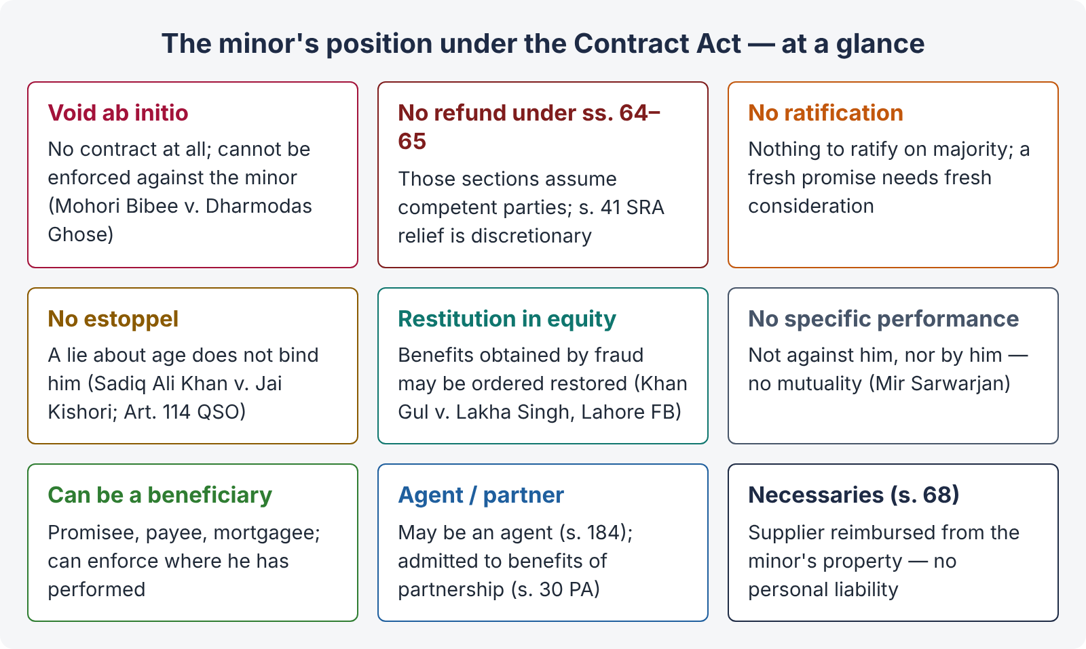
Figure 3 · The minor's position under the Contract Act — at a glance

4.4 Persons of unsound mind — s. 12
"12. A person is said to be of sound mind for the purpose of making a contract if, at the time when he makes it, he is capable of understanding it and of forming a rational judgment as to its effect upon his interests. A person who is usually of unsound mind, but occasionally of sound mind, may make a contract when he is of sound mind. A person who is usually of sound mind, but occasionally of unsound mind, may not make a contract when he is of unsound mind."
Illustrations: (a) a patient in a lunatic asylum may contract during lucid intervals; (b) a sane man delirious from fever or so drunk that he cannot understand the terms cannot contract while the delirium or drunkenness lasts.

The two-part test
- Understanding — can he understand the nature of the transaction?
- Rational judgment — can he judge its effect on his own interests?
The relevant time is the time of making the contract. The burden of proof: a person is presumed sane; whoever alleges unsoundness must prove it. But if a person is shown to be usually of unsound mind, the burden shifts to the person who says the contract was made in a lucid interval.

Effect
The Act treats a person of unsound mind like a minor: his agreement is void (ss. 10–12, following Mohori Bibee), with liability for necessaries from his property (s. 68). Other cases of incapacity:
- Illness, old age, brain injury — the question is always the s. 12 test at the time. Weakness short of incapacity may still matter under undue influence (s. 16(2)(b): "mental capacity temporarily or permanently affected by reason of age, illness, or mental or bodily distress").
- Intoxication — illustration (b) to s. 12.
- Mental Health Ordinance 2001 — a court may appoint a manager or guardian for the property of a mentally disordered person; contracts relating to such property must then be made through that manager.

4.5 Persons disqualified by law
The Act refers to persons "disqualified from contracting by any law to which he is subject". Examples:
- Alien enemies — cannot sue in Pakistani courts without the Federal Government's permission (s. 83, CPC); contracts with alien enemies during war are void or suspended on grounds of public policy.
- Foreign States, rulers and diplomats — cannot be sued without the consent of the Federal Government (s. 86, CPC; State Immunity Ordinance 1981), though they can contract.
- Insolvents — an undischarged insolvent cannot deal with property vested in the official receiver or assignee.
- Companies and statutory bodies — can contract only within their objects and powers; a contract ultra vires a statutory corporation is void.
- Public servants — may be prohibited by service rules from certain contracts (e.g., purchasing property at auctions they conduct).
QUICK RECAP · Chapter 4 in seven lines
- Competent = major (18; 21 if court guardian) + sound mind + not disqualified (s. 11; Majority Act s. 3).
- Minor's agreement is void ab initio; no refund under ss. 64–65 (Mohori Bibee).
- No ratification; no estoppel (Sadiq Ali Khan); restitution of fraud benefits in equity (Khan Gul, Lahore FB; contrast Ajudhia Prasad; Leslie v. Sheill).
- No specific performance either way (Mir Sarwarjan); minor can be promisee / beneficiary / agent / admitted to partnership benefits.
- Necessaries — reimbursement from property only (s. 68; Nash v. Inman).
- Unsound mind: capable of understanding + rational judgment at the time (s. 12); lucid intervals; drunkenness.
- Disqualified: alien enemies (s. 83 CPC), foreign states (s. 86 CPC), insolvents, ultra vires bodies.

Chapter 5 · Free consent (ss. 13 to 22)

5.1 Consent and free consent
"13. Two or more persons are said to consent when they agree upon the same thing in the same sense."
This is consensus ad idem — a meeting of minds. If there is no consent at all (the parties are at cross-purposes about the very thing), the agreement is void.
CASE STUDY · Raffles v. Wichelhaus ((1864) 2 H & C 906)
Facts. Cotton was sold "to arrive ex Peerless from Bombay". There were two ships called Peerless, sailing in October and December. The buyer meant one, the seller the other.
Held. There was no consensus ad idem, so no contract.

"14. Consent is said to be free when it is not caused by— (1) coercion, as defined in section 15, or (2) undue influence, as defined in section 16, or (3) fraud, as defined in section 17, or (4) misrepresentation, as defined in section 18, or (5) mistake, subject to the provisions of sections 20, 21 and 22. Consent is said to be so caused when it would not have been given but for the existence of such coercion, undue influence, fraud, misrepresentation or mistake."
The last paragraph lays down a "but for" causation test: the defect must have caused the consent. If a person would have entered the contract anyway, he cannot avoid it.
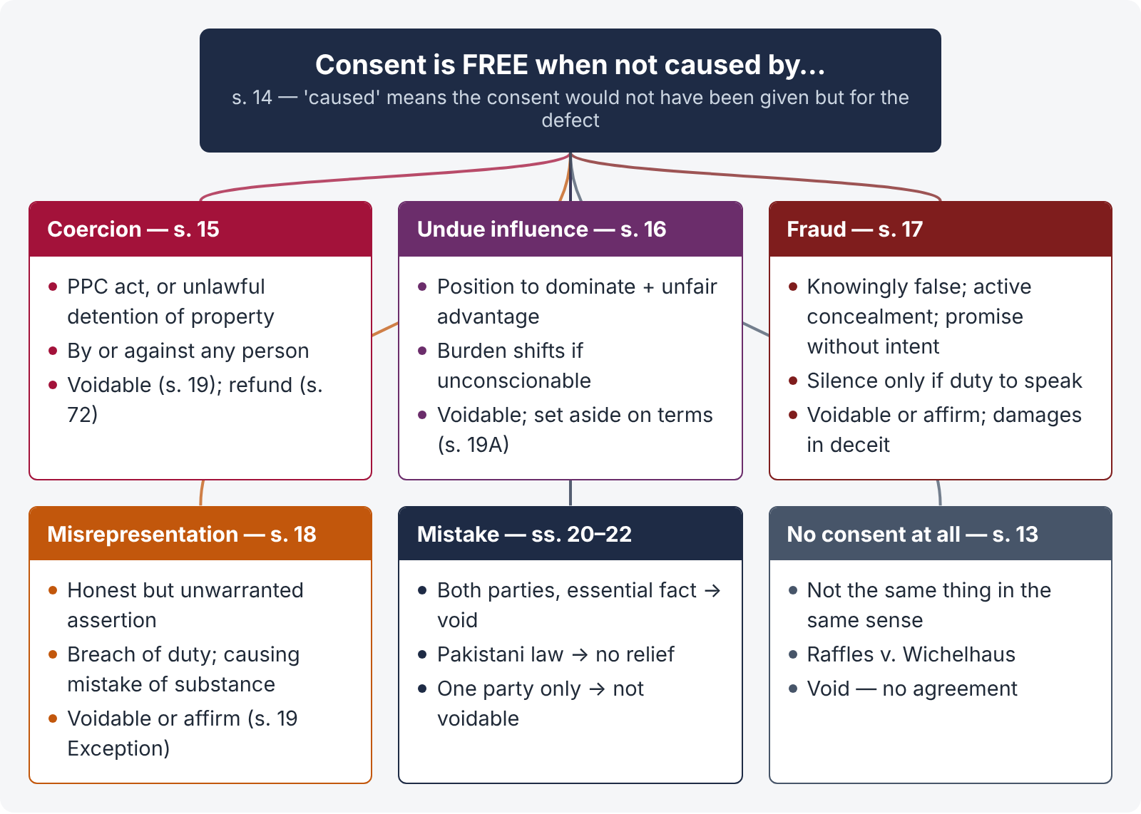
Figure 4 · Free consent — the five defects and their effect
Defect | Effect on the agreement | Section
Coercion | Voidable at the option of the party coerced | s. 19
Undue influence | Voidable; may be set aside absolutely or on terms | s. 19A
Fraud | Voidable; or affirm and claim to be put in the position as if the representation were true; plus damages in tort | s. 19
Misrepresentation | Voidable; or affirm and insist on performance as if true | s. 19
Mistake of fact — both parties, essential fact | Void | s. 20
Mistake of Pakistani law | Not voidable | s. 21
Mistake of foreign law | Same as mistake of fact | s. 21
Mistake of one party only | Not voidable (subject to exceptions) | s. 22

5.2 Coercion — s. 15
"15. 'Coercion' is the committing, or threatening to commit, any act forbidden by the Pakistan Penal Code (XLV of 1860) or the unlawful detaining, or threatening to detain, any property, to the prejudice of any person whatever, with the intention of causing any person to enter into an agreement. Explanation.— It is immaterial whether the Pakistan Penal Code is or is not in force in the place where the coercion is employed."
Illustration: A, on board an English ship on the high seas, causes B to enter into an agreement by an act amounting to criminal intimidation under the PPC. A later sues B at Karachi. A has employed coercion, though the act is not an offence by English law.

Ingredients
- Committing or threatening an act forbidden by the PPC, or unlawfully detaining or threatening to detain property;
- to the prejudice of any person whatever — the threat may be directed at a third person (e.g., the victim's son), and may be made by anyone, not necessarily a party;
- with the intention of causing any person to enter into an agreement.
CASE STUDY · Chikham Amiraju v. Chikham Seshamma ((1917) ILR 41 Mad 33)
Facts. A Hindu husband threatened to commit suicide unless his wife and son executed a release in favour of his brother regarding certain property. They executed it.
Held. (Majority) The threat of suicide was coercion. Attempt to commit suicide was punishable under the Penal Code (s. 309), so a threat to commit it is a threat to commit an act "forbidden" by the Code. The release was voidable.
Note for Pakistan. Attempted suicide (s. 325 PPC) was decriminalised by the Criminal Laws (Amendment) Act 2022, so the same facts today would more naturally fall under undue influence or general pressure. Mention this as a point of analysis.

CASE STUDY · Ranganayakamma v. Alwar Setti ((1889) ILR 13 Mad 214)
Facts. A 13-year-old widow was prevented by relatives of her late husband from removing his body for cremation until she adopted a boy of their choosing.
Held. The adoption was not binding; her consent was obtained by coercion (obstructing a corpse's removal for funeral rites is an offence under the Penal Code — s. 297).

Coercion vs duress (English law)
Point | Coercion (Pakistani Act) | Duress (English common law)
Acts covered | Any act forbidden by the PPC + unlawful detention of property | Originally violence or threats to the person; now also economic duress
Against whom | "Any person whatever" — a stranger too | Originally the contracting party or close family
By whom | Any person, even a stranger to the contract | Party or with his knowledge
Penal Code | Immaterial whether in force where used | —

Economic duress. English law now recognises economic duress — illegitimate commercial pressure, such as a threat to break a contract unless more money is paid (Pao On v. Lau Yiu Long [1980] AC 614; The Atlantic Baron [1979] QB 705). Under our Act, such pressure is not "coercion" unless it involves a PPC offence or unlawful detention of property, but it may amount to undue influence (where there is domination) or be relevant to s. 72 (money paid under coercion).
s. 72. "A person to whom money has been paid, or anything delivered, by mistake or under coercion, must repay or return it." (Chapter 11.)

5.3 Undue influence — ss. 16 and 19A
"16. (1) A contract is said to be induced by 'undue influence' where the relations subsisting between the parties are such that one of the parties is in a position to dominate the will of the other and uses that position to obtain an unfair advantage over the other. (2) In particular and without prejudice to the generality of the foregoing principle, a person is deemed to be in a position to dominate the will of another— (a) where he holds a real or apparent authority over the other or where he stands in a fiduciary relation to the other; or (b) where he makes a contract with a person whose mental capacity is temporarily or permanently affected by reason of age, illness, or mental or bodily distress. (3) Where a person who is in a position to dominate the will of another, enters into a contract with him, and the transaction appears, on the face of it or on the evidence adduced, to be unconscionable, the burden of proving that such contract was not induced by undue influence shall lie upon the person in a position to dominate the will of the other. Nothing in this sub-section shall affect the provisions of section 111 of the Evidence Act, 1872 [now Article 127, Qanun-e-Shahadat 1984]."
Illustrations: (a) a father, by misusing parental influence, obtains from his son just come of age a bond for more than is due — undue influence; (b) a medical attendant induces an old, sick patient to pay an unreasonable fee — undue influence; (c) a village money-lender's fresh loan on unconscionable terms — burden on the lender; (d) a bank charging a high rate during money-market stringency — ordinary business, not undue influence.

The three questions — Raghunath Prasad
CASE STUDY · Raghunath Prasad v. Sarju Prasad ((1923) 51 IA 101, Privy Council)
Facts. A Hindu, involved in litigation with his father and in urgent need of money, borrowed Rs. 10,000 at 24 % compound interest. The lender later sued for over Rs. 1,00,000.
Held. The court must ask in order:
- Were the relations between the parties such that one was in a position to dominate the will of the other?
- If yes, has he used that position to obtain an unfair advantage?
- If the transaction is unconscionable, the burden shifts to the dominant party to prove that it was not induced by undue influence.
Mere urgent need for money and a high rate of interest do not by themselves show that the lender was in a position to dominate the borrower's will. Undue influence was not proved; but the court reduced compound interest to simple interest under its equitable powers.

Relationships of domination (presumed)
- Real authority — father and son, guardian and ward, employer and employee (in some cases), religious or spiritual adviser and disciple (Mannu Singh v. Umadat Pande, (1890) ILR 12 All 523 — a guru induced a disciple to gift all his property).
- Apparent authority — a police officer and an accused, a revenue officer and a cultivator.
- Fiduciary relation — trustee and beneficiary, solicitor (advocate) and client, doctor and patient, spiritual adviser and devotee.
- Mental distress — age, illness, bodily or mental distress (s. 16(2)(b)).

Pardanashin and illiterate women
CASE STUDY · Farid-un-Nisa v. Mukhtar Ahmad ((1925) 52 IA 342, Privy Council)
Held. Where a pardanashin woman executes a deed, the person relying on it must prove affirmatively that the deed was explained to her and understood by her, that it was her free and intelligent act, and ideally that she had independent advice. The burden is on the person who seeks to benefit from the deed.

Pakistani courts apply this protective rule broadly to illiterate, old or dependent women and to transactions by which a woman gives up her inheritance (e.g., Mst. Janat Bibi v. Sikandar Ali, PLD 1990 SC 642: where a pardanashin or illiterate woman is said to have transferred property, the beneficiary must prove the transaction was explained to her, understood, and made with independent advice). Article 127 of the Qanun-e-Shahadat places the burden of proving good faith on the person who stood in a position of active confidence.

Guarantees given by a wife or parent for a family member's debts
CASE STUDY · Lloyds Bank Ltd. v. Bundy ([1975] QB 326)
Facts. An elderly farmer, who had banked with Lloyds for years and relied on its manager, mortgaged his only asset — his farmhouse — to guarantee his son's failing company's debts, on the manager's advice. He received no independent advice.
Held. The transaction was set aside. A relationship of confidence existed; the bank had a conflict of interest and should have ensured that the father got independent advice.

CASE STUDY · Royal Bank of Scotland v. Etridge (No. 2) ([2001] UKHL 44)
Held. When a wife (or other person in a non-commercial relationship) stands surety for her husband's debts, the bank is "put on inquiry". To protect itself, it must take reasonable steps to ensure that the surety had the transaction explained by an independent legal adviser. If it does not, it is affected by any undue influence or misrepresentation by the husband. (Earlier: Barclays Bank v. O'Brien [1994] 1 AC 180.)

Effect — s. 19A
"19A. When consent to an agreement is caused by undue influence, the agreement is a contract voidable at the option of the party whose consent was so caused. Any such contract may be set aside either absolutely or, if the party who was entitled to avoid it has received any benefit thereunder, upon such terms and conditions as to the Court may seem just."
Illustration (b) to s. 19A: a money-lender advances Rs. 100 and by undue influence takes a bond for Rs. 200 at 6 % per month. The court may set aside the bond, ordering repayment of Rs. 100 with such interest as is just.
Point | Coercion | Undue influence
Nature | Physical / criminal compulsion | Mental / moral pressure
Relationship | Not needed — anyone, even a stranger | Essential — one dominates the other's will
Act | Offence under PPC or unlawful detention of property | Unfair use of dominant position
Benefit | Need not be to the coercer | Unfair advantage to the dominant party
Burden | On the person alleging | Shifts to the dominant party if unconscionable (s. 16(3))
Remedy | Voidable (s. 19); s. 72 refund | Voidable; set aside absolutely or on terms (s. 19A)

5.4 Fraud — s. 17
"17. 'Fraud' means and includes any of the following acts committed by a party to a contract, or with his connivance, or by his agent, with intent to deceive another party thereto or his agent, or to induce him to enter into the contract:— (1) the suggestion, as a fact, of that which is not true, by one who does not believe it to be true; (2) the active concealment of a fact by one having knowledge or belief of the fact; (3) a promise made without any intention of performing it; (4) any other act fitted to deceive; (5) any such act or omission as the law specially declares to be fraudulent. Explanation.— Mere silence as to facts likely to affect the willingness of a person to enter into a contract is not fraud, unless the circumstances of the case are such that, regard being had to them, it is the duty of the person keeping silence to speak, or unless his silence is, in itself, equivalent to speech."

Ingredients
- A representation (or concealment) of fact — not opinion, puffery or a statement of law;
- false, and made knowingly, or without belief in its truth, or recklessly careless whether true or false;
- by a party (or with his connivance or by his agent);
- with intent to deceive or induce;
- the other party acted on it (was actually deceived and induced — s. 19 Explanation); and
- (for damages) suffered loss.
CASE STUDY · Derry v. Peek ((1889) 14 App Cas 337, House of Lords)
Facts. A company's prospectus said it had the right to use steam power for its trams. In fact, Board of Trade consent was needed and was later refused. The directors honestly believed consent would be a formality.
Held. Fraud is proved when a false representation is made (i) knowingly, (ii) without belief in its truth, or (iii) recklessly, careless whether it be true or false. An honest belief, however unreasonable, is not fraud. The directors were not liable in deceit.
Lesson. Honest but careless statements are misrepresentation (s. 18), not fraud (s. 17).

Silence — when it is fraud
Illustrations to s. 17:
- (a) A sells by auction a horse he knows to be unsound, saying nothing — not fraud (caveat emptor).
- (b) The buyer is A's daughter just come of age — the relationship creates a duty to speak.
- (c) B says: "If you do not deny it, I shall assume the horse is sound." A says nothing — silence is equivalent to speech.
- (d) Traders; A has private information of a price change — A is not bound to inform B.
Duty to speak arises:
- in contracts uberrimae fidei (of the utmost good faith) — insurance, family settlements, partnership, company prospectuses;
- in fiduciary relationships;
- where a statement true when made becomes false before the contract (With v. O'Flanagan [1936] Ch 575 — the value of a medical practice fell before sale);
- where a half-truth misleads (telling part of the truth so that the whole is false);
- where a statute requires disclosure — e.g., s. 55(1)(a), Transfer of Property Act: the seller of immovable property must disclose material defects in the property or title of which he is aware and the buyer is not, and which the buyer could not discover with ordinary care.
LEGAL MAXIM · Caveat emptor — let the buyer beware
In general, a party need not volunteer facts; each party must look after his own interests. The Act's Explanation to s. 17 and s. 16 of the Sale of Goods Act reflect this rule — subject to the exceptions above.

ISLAMABAD-SPECIFIC LAW · Sale of goods in Pakistan — the seller must disclose defects
For sales of goods, Pakistan has cut down the silence rule by statute. Section 16A of the Sale of Goods Act (inserted by Act XVIII of 1994) provides that, "notwithstanding anything contained in section 16, and save where the parties have entered into an agreement to the contrary, the seller shall be under an obligation to inform the buyer of any defect in the goods sold at the time of the contract, except in a case where the defect is obviously known to the buyer." So a Pakistani seller of goods who keeps quiet about a defect breaches a statutory duty, even where the general rule in s. 17 would treat mere silence as no fraud. (Full treatment: Topic 4, Chapter 7.)

Promise without intention to perform
A promise made without intending to perform it is fraud (s. 17(3)) — e.g., buying goods on credit with no intention to pay.

Remedies for fraud
- Rescind the contract (s. 19) — voidable at the option of the deceived party;
- affirm it and insist on being put in the position he would have been in if the representation were true (s. 19, second para; illustration (c) — estate represented free from mortgage: buyer may insist on the mortgage being redeemed);
- damages — fraud is also the tort of deceit;
- restoration on rescission (s. 64).

5.5 Misrepresentation — s. 18
"18. 'Misrepresentation' means and includes— (1) the positive assertion, in a manner not warranted by the information of the person making it, of that which is not true, though he believes it to be true; (2) any breach of duty which, without an intent to deceive, gains an advantage to the person committing it, or any one claiming under him, by misleading another to his prejudice …; (3) causing, however innocently, a party to an agreement to make a mistake as to the substance of the thing which is the subject of the agreement."
Point | Fraud (s. 17) | Misrepresentation (s. 18)
Belief | Maker knows it is false, or is reckless | Maker honestly believes it to be true
Intent | Intent to deceive | No intent to deceive
Remedy | Rescind or affirm; damages in tort of deceit | Rescind or affirm; no damages for innocent misrepresentation (generally)
Silence | Can be fraud if duty to speak | Ordinarily not, unless breach of duty under s. 18(2)
s. 19 Exception | Does not protect active fraud; protects only fraudulent silence | Not voidable if truth discoverable with ordinary diligence

When the contract is not voidable — s. 19 Exception and Explanation
"Exception.— If such consent was caused by misrepresentation or by silence, fraudulent within the meaning of section 17, the contract, nevertheless, is not voidable, if the party whose consent was so caused had the means of discovering the truth with ordinary diligence. Explanation.— A fraud or misrepresentation which did not cause the consent … does not render a contract voidable."
Illustration (b) to s. 19: B examined the accounts showing only 400 maunds (not 500) — he was not misled, so the contract is not voidable.
COMMON MISTAKE · The Exception does not cover active fraud
The s. 19 Exception applies only to misrepresentation and fraudulent silence. A person who tells a deliberate lie cannot say, "You could have found out." (Compare the English rule in Redgrave v. Hurd (1881) 20 Ch D 1: it is no defence that the misled party could have discovered the truth.)

5.6 Mistake — ss. 20, 21, 22

Bilateral mistake of fact — s. 20
"20. Where both the parties to an agreement are under a mistake as to a matter of fact essential to the agreement, the agreement is void. Explanation.— An erroneous opinion as to the value of the thing which forms the subject-matter of the agreement is not to be deemed a mistake as to a matter of fact."
Illustrations: (a) cargo supposed to be on its way from England to Karachi had already been lost — void; (b) a horse already dead — void; (c) an estate for B's life sold when B was already dead — void.
Kinds of operative bilateral mistake:
- As to the existence of the subject-matter (res extincta) — Couturier v. Hastie (1856) 5 HLC 673: a cargo of corn had already been sold by the ship's master because it was fermenting; contract void. (Also s. 7, Sale of Goods Act.)
- As to title (res sua) — buying what already belongs to the buyer (Cooper v. Phibbs (1867) LR 2 HL 149).
- As to identity of the subject-matter (Raffles v. Wichelhaus — really no consensus).
- As to quantity, price or a fundamental quality that makes the thing essentially different from what was supposed.
CASE STUDY · Bell v. Lever Brothers Ltd. ([1932] AC 161, House of Lords)
Facts. Lever Brothers paid large compensation to two directors to terminate their service contracts, not knowing (nor did the directors have it in mind) that the directors had committed breaches that would have allowed dismissal without compensation.
Held. The agreement was not void. A mistake as to quality makes a contract void only if it makes the thing essentially and radically different from what it was believed to be. Here Lever got what it bargained for — termination of the contracts.

Mistake of law — s. 21
"21. A contract is not voidable because it was caused by a mistake as to any law in force in Pakistan; but a mistake as to a law not in force in Pakistan has the same effect as a mistake of fact."
Illustration: A and B contract on the erroneous belief that a debt is barred by the Pakistan law of limitation — the contract is not voidable.
LEGAL MAXIM · Ignorantia juris non excusat — ignorance of the law is no excuse
Everyone is presumed to know the law of his own country. Foreign law, however, is a matter of fact to be proved, so a mistake about it is treated like a mistake of fact.

LEGAL MAXIM · Ignorantia facti excusat — ignorance of fact excuses
A genuine mistake of fact may excuse — which is why s. 20 treats bilateral mistake of fact as making the agreement void.

Unilateral mistake — s. 22
"22. A contract is not voidable merely because it was caused by one of the parties to it being under a mistake as to a matter of fact."
Rationale. If one party's private mistake could undo a contract, no contract would be safe. The other party is entitled to rely on outward appearances (the objective theory of contract).
CASE STUDY · Smith v. Hughes ((1871) LR 6 QB 597)
Facts. A buyer bought oats after seeing a sample, believing them to be old oats; they were new oats. The seller said nothing about their age.
Held. The buyer's mistake as to quality did not affect the contract, as long as the seller had not represented them as old oats and the contract did not term them "old". Silence about the buyer's mistake as to quality is not fraud (caveat emptor). (In a Pakistani sale of goods, compare the seller's statutory duty to disclose defects under SGA s. 16A — a mistake about the age of oats is not a defect, but a hidden flaw would be.)

Exceptions — when unilateral mistake matters:
- Mistake as to identity of the other party, where identity is vital to the contract — the contract is void.
CASE STUDY · Cundy v. Lindsay ((1878) 3 App Cas 459)
Facts. A rogue named Blenkarn, writing from 37 Wood Street, signed his letters to look like "Blenkiron & Co.", a respectable firm at 123 Wood Street. Lindsay sent goods to him. He sold them to Cundy, an innocent buyer.
Held. Lindsay intended to contract only with Blenkiron & Co.; there was no contract with Blenkarn (void). Blenkarn got no title, so Cundy got none and had to return the goods.

CASE STUDY · Phillips v. Brooks Ltd. ([1919] 2 KB 243)
Facts. A rogue in a jeweller's shop said he was "Sir George Bullough" and was allowed to take a ring on credit. He pledged it with Brooks.
Held. In a face-to-face dealing, the seller is presumed to intend to deal with the person in front of him, whoever he is. The contract was voidable for fraud, not void; Brooks, who took the ring in good faith before avoidance, got a good title. (Followed in Lewis v. Averay [1972] 1 QB 198; Ingram v. Little [1961] 1 QB 31 went the other way on its facts; Shogun Finance v. Hudson [2003] UKHL 62 confirmed the written-contract / face-to-face distinction.)

- Mistake as to the nature of the document signed — *non est factum* ("it is not my deed").
CASE STUDY · Foster v. Mackinnon ((1869) LR 4 CP 704)
Facts. An old man with poor eyesight was told the paper he signed was a guarantee; it was in fact a bill of exchange.
Held. He was not liable, even to an innocent endorsee: his mind did not go with his signature, as he was deceived about the very nature of the document, and he was not negligent.

CASE STUDY · Saunders v. Anglia Building Society (Gallie v. Lee) ([1971] AC 1004, House of Lords)
Facts. An elderly widow signed, without reading (her glasses were broken), a document which she was told was a gift of her house to her nephew. It was in fact a sale to the nephew's business partner, who mortgaged the house.
Held. The plea of non est factum failed. It is available only where (i) the document signed is radically or fundamentally different from what the signer believed, and (ii) the signer was not careless in signing. Here the document had the same object — to transfer her house so that money could be raised — and she had been careless.

- Where the other party knew of the mistake about the terms (not mere quality) — the contract may not bind (e.g., Hartog v. Colin & Shields [1939] 3 All ER 566 — an obvious price-per-pound vs price-per-piece error that the buyer must have noticed).
COMMON MISTAKE · Mistake is not the same as fraud
A mistake caused by the other party's false statement is dealt with under fraud or misrepresentation (ss. 17–19) — voidable. Mistake under ss. 20–22 is a mistake not induced by the other party. Misrepresentation s. 18(3) covers innocently causing a mistake as to substance.

QUICK RECAP · Chapter 5 in nine lines
- Consent = same thing in same sense (s. 13; Raffles v. Wichelhaus). Free consent = not caused by the five defects ("but for" test, s. 14).
- Coercion: PPC act or unlawful detention of property, by anyone, against anyone (s. 15; Chikham Amiraju; Ranganayakamma). Voidable (s. 19); refund (s. 72).
- Undue influence: domination + unfair advantage; burden shifts if unconscionable (s. 16; Raghunath Prasad); pardanashin rule (Farid-un-Nisa; Art. 127 QSO); guarantees (Bundy, Etridge). Voidable / set aside on terms (s. 19A).
- Fraud: knowingly false, active concealment, promise without intent, any act fitted to deceive (s. 17; Derry v. Peek). Silence not fraud unless duty to speak or equivalent to speech.
- Misrepresentation: honest but unwarranted assertion; breach of duty; innocently causing mistake as to substance (s. 18).
- Remedies: rescind or affirm (s. 19); Exception — not for misrepresentation / fraudulent silence if truth discoverable with ordinary diligence; consent must be caused (Explanation).
- Bilateral mistake of essential fact — void (s. 20; Couturier; Bell v. Lever on quality). Value opinion is not mistake.
- Mistake of Pakistani law — no relief; foreign law = fact (s. 21).
- Unilateral mistake — not voidable (s. 22; Smith v. Hughes), except identity (Cundy vs Phillips) and non est factum (Foster v. Mackinnon; Saunders).

Chapter 6 · Lawful consideration and lawful object (ss. 23, 24)

6.1 Consideration and object — two different things
- Consideration is what each party gives or promises in exchange — the price of the promise (s. 2(d)).
- Object is the purpose or design of the agreement — what the parties want to achieve by it.
Usually the two coincide, but not always. Example: A lends B Rs. 500,000 (consideration — the loan), but both know B will use it to bribe an official (object). The consideration (money) is lawful in itself, but the object is unlawful, so the agreement is void. (This is the LHC ASJ 2020 question.)

6.2 When are they unlawful — s. 23
"23. The consideration or object of an agreement is lawful, unless— it is forbidden by law; or is of such a nature that, if permitted, it would defeat the provisions of any law; or is fraudulent; or involves or implies injury to the person or property of another; or the Court regards it as immoral, or opposed to public policy. In each of these cases, the consideration or object of an agreement is said to be unlawful. Every agreement of which the object or consideration is unlawful is void."
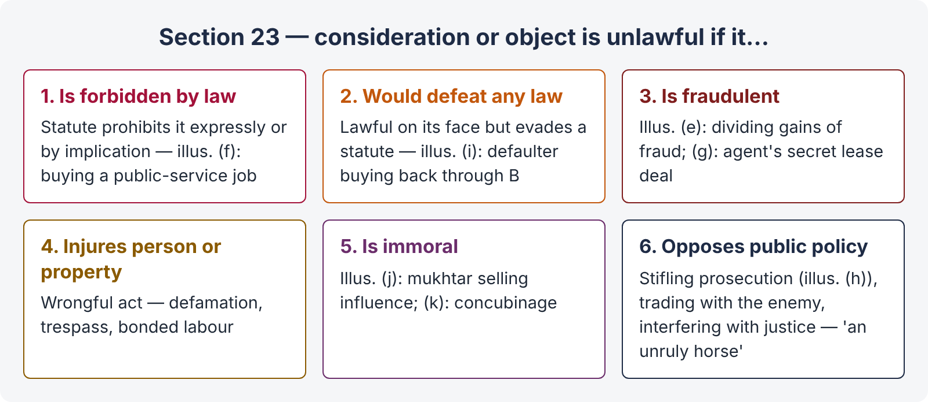
Figure 5 · Section 23 — the six heads of unlawfulness

Head 1 — Forbidden by law
Anything prohibited by a statute, rule or regulation having the force of law — whether expressly or by necessary implication (e.g., where a statute imposes a penalty on doing an act without a licence, and its purpose is to protect the public). Illustration (f): A promises to obtain for B an employment in the public service, and B promises to pay Rs. 1,000 — void (sale of public office; also an offence of bribery).
- A contract to sell narcotics, to smuggle goods, or to sell a liquor permit — forbidden.
- An agreement to pay a bribe for a government contract.
- Riba — see Chapter 12 for how interest stipulations are viewed in Pakistan today.
Not every statutory requirement makes a contract void: if a statute merely imposes a penalty for revenue purposes (e.g., non-registration of a trader for tax), the contract itself may remain valid. The test is the object of the statute — whether it intended to prohibit the contract.

Head 2 — Would defeat the provisions of any law
An act lawful on its face, but which, if allowed, would circumvent a statute. Illustration (i): an estate sold for arrears of revenue; the law forbids the defaulter to buy it; B buys it on an understanding to reconvey to A — void, as it defeats the law. Similar: a benami purchase to defeat creditors; an agreement to evade stamp duty or taxes.

Head 3 — Fraudulent
Illustration (e): A, B and C agree to divide gains acquired by fraud — void. Illustration (g): an agent agrees, without his principal's knowledge, to obtain for B a lease of the principal's land for money — void (fraud by concealment on the principal).

Head 4 — Injury to person or property of another
"Injury" means a wrongful act — criminal or tortious. Examples: an agreement to publish a defamatory statement; to infringe copyright; to commit trespass. A loan bond under which the debtor would work for the creditor without wages until repayment (bonded labour) is void as injurious to the person — and now an offence under the Bonded Labour System (Abolition) Act 1992.

Head 5 — Immoral
"Immoral" in s. 23 is understood as sexual immorality and similar matters the court regards as contrary to accepted moral standards — not every moral failing. Illustration (k): A agrees to let her daughter to hire to B for concubinage — void, though the letting may not be punishable. Illustration (j): A, who is B's mukhtar, promises to use his influence with B in favour of C, for Rs. 1,000 — void as immoral. A landlord who knowingly lets premises for prostitution cannot recover rent (Pearce v. Brooks (1866) LR 1 Ex 213 — hire of a carriage to a prostitute for her trade).

Head 6 — Opposed to public policy
"Public policy" means the interest of the public — the principle that no one may lawfully do what tends to injure the public or is against the public good.
LEGAL MAXIM · Public policy is "a very unruly horse"
"…and when once you get astride it you never know where it will carry you" — Burrough J in Richardson v. Mellish (1824) 2 Bing 229. Courts therefore apply the doctrine cautiously, within established heads, and should not invent new heads lightly (Gherulal Parakh v. Mahadeodas Maiya, AIR 1959 SC 781).

Established heads of public policy:
- Trading with an enemy in wartime.
- Stifling prosecution — illustration (h): A promises to drop a robbery prosecution if B restores the value of the things taken — void. (A compromise of a compoundable offence under s. 345, CrPC, with the court's permission where required, is lawful. Also, where a civil dispute is settled and the criminal complaint is withdrawn, the settlement is valid unless the withdrawal was part of the consideration: Kamini Kumar Basu v. Birendra Nath Basu, AIR 1930 PC 100.)
- Interference with the course of justice — bribing a witness or judge; an agreement to give false evidence.
- Maintenance and champerty — see below.
- Sale of public offices and titles; agreements to procure government employment (illustration (f)).
- Marriage brokerage — paying a person to procure a marriage is contrary to public policy (in some cases).
- Agreements in restraint of marriage, trade, or legal proceedings (ss. 26–28 — made expressly void).
- Creating monopolies and agreements affecting the freedom of trade (now also the Competition Act 2010).
- Agreements tending to create interest against duty — e.g., a public servant or agent agreeing to take a secret profit.
- Agreements to defraud the revenue or creditors.

Maintenance and champerty
- Maintenance: helping another to bring or defend a suit in which the helper has no interest.
- Champerty: maintenance in return for a share of the property or proceeds recovered.
CASE STUDY · Ram Coomar Coondoo v. Chunder Canto Mookerjee ((1876) ILR 2 Cal 233, Privy Council)
Held. The English law of maintenance and champerty does not apply as such in the subcontinent. A fair agreement to supply funds for litigation in return for a share of the result is not in itself void. It is void only if it is extortionate or unconscionable, or made for an improper object (e.g., gambling in litigation, injuring others, or oppressing the defendant).

Advocates. Under the professional conduct rules (Pakistan Legal Practitioners and Bar Councils Act 1973 and the Canons of Professional Conduct and Etiquette), an advocate may not stipulate for a share in the subject matter of litigation (a contingency fee by share) — that is professional misconduct even if not void under s. 23.

6.3 The effect of illegality
LEGAL MAXIM · Ex turpi causa non oritur actio — no action arises from a base cause
A court will not help a person who founds his claim on an illegal or immoral act. Lord Mansfield in Holman v. Johnson (1775) 1 Cowp 341: "No court will lend its aid to a man who founds his cause of action upon an immoral or an illegal act." This rule is not for the benefit of the defendant; it is a rule of public policy — the court protects its own integrity.

LEGAL MAXIM · In pari delicto potior est conditio defendentis — where both are equally at fault, the defendant's position is stronger
Money paid or property delivered under an illegal agreement cannot generally be recovered. The loss lies where it falls.

Exceptions — recovery may be allowed:
- Where the parties are not in pari delicto — e.g., one party was a victim of fraud, coercion or undue influence, or the law was meant to protect that class of persons (Kiriri Cotton Co. v. Dewani [1960] AC 192, PC — a tenant who paid an illegal premium could recover it, because the rent law aimed to protect tenants).
- Locus poenitentiae — a party who repents and withdraws before the illegal purpose is carried out may recover what he paid (Taylor v. Bowers (1876) 1 QBD 291).
- Where the claim can be proved without relying on the illegality — e.g., a claim based on independent title.

Collateral transactions
When the main agreement is illegal (forbidden by law, immoral, etc.), agreements collateral to it — knowingly made to help carry it out — are also void. But when an agreement is merely void (not illegal — e.g., a wager in India), collateral agreements are valid. In Pakistan, ss. 30A–30C expressly make agreements collateral to wagers void (Chapter 7).
Point | Void agreement | Illegal agreement
Scope | Wider: every illegal agreement is void | Narrower: not every void agreement is illegal
Punishment | Parties not punished | Parties may be punished (e.g., PPC)
Collateral transactions | Valid (except wagers in Pakistan — s. 30A) | Also tainted and void
Restitution | s. 65 may apply when discovered to be void | Generally no recovery (in pari delicto), subject to exceptions
Examples | Minor's agreement; agreement without consideration; restraint of trade | Smuggling; bribery; concubinage; stifling prosecution

6.4 Partial illegality — s. 24 and severability
"24. If any part of a single consideration for one or more objects, or any one or any part of any one of several considerations for a single object, is unlawful, the agreement is void."
Illustration: A promises to superintend, for B, a legal manufacture of indigo and an illegal traffic in other articles, for a salary of Rs. 10,000 a year — void, because the single consideration (salary) is for objects partly unlawful and cannot be apportioned.
Severability. Where the lawful part can be separated from the unlawful part, the lawful part stands. This is what s. 57 (reciprocal promises: legal and illegal acts) and s. 58 (alternative promise, one branch illegal) provide:
- s. 57: where persons promise to do certain things which are legal, and also, under specified circumstances, certain things which are illegal, the first set is a contract and the second a void agreement. Illustration: A agrees to sell B a house for Rs. 10,000, but if B uses it as a gambling house, he shall pay Rs. 50,000 — the first is valid, the second void.
- s. 58: in an alternative promise, one branch legal and the other illegal, only the legal branch can be enforced. Illustration: A and B agree that A shall pay B Rs. 1,000, for which B shall afterwards deliver either rice or smuggled opium — valid for rice, void for opium.
QUICK RECAP · Chapter 6 in six lines
- Consideration = price; object = purpose. Both must be lawful (s. 23).
- Six heads: forbidden by law; defeats any law; fraudulent; injury to person or property; immoral; opposed to public policy.
- Public policy — "unruly horse"; established heads only (Gherulal Parakh); stifling prosecution, trading with enemy, sale of offices, interference with justice; champerty not void unless unconscionable (Ram Coomar Coondoo).
- Ex turpi causa; in pari delicto — no recovery, except not in pari delicto (Kiriri Cotton), locus poenitentiae, independent title.
- Illegal agreements taint collateral transactions; merely void ones do not (except wagers in Pakistan, s. 30A).
- s. 24: single consideration partly unlawful — wholly void; severable parts saved (ss. 57, 58).

Chapter 7 · Agreements expressly declared void (ss. 26 to 30C)
The Act lists agreements it expressly declares void. Together with s. 25 (no consideration), s. 24 (partly unlawful), s. 20 (bilateral mistake) and s. 56 (impossibility), they form the list in s. 10 ("not hereby expressly declared to be void").
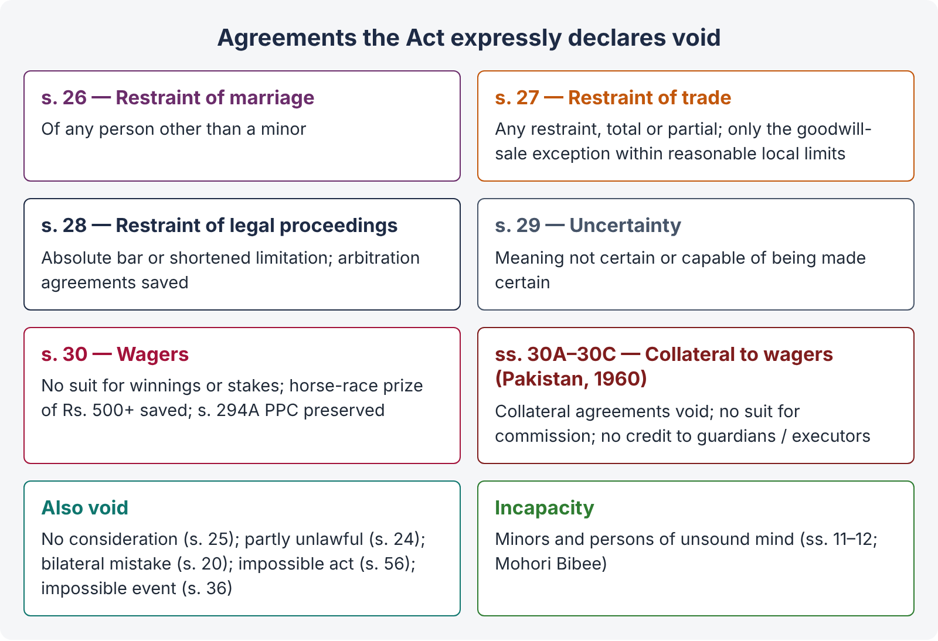
Figure 6 · Agreements expressly declared void

7.1 Restraint of marriage — s. 26
"26. Every agreement in restraint of the marriage of any person, other than a minor, is void."
Rationale. Marriage is a fundamental personal freedom and a social institution; nobody should be paid or bound to give it up. Examples: A promises B Rs. 1 million if B never marries — void. A promise not to marry anyone other than a particular person has also been held void. An agreement in restraint of the marriage of a minor is not covered — indeed restraining child marriage is in line with the Child Marriage Restraint Act 1929 and the ICT Child Marriage Restraint Act 2025 (fixing 18 years for both).
Note that conditions in a nikahnama (e.g., a stipulation that the husband will not take a second wife without the first wife's consent, or the delegation of the right of divorce — talaq-e-tafweez) are not "restraint of marriage" agreements under s. 26; they are regulated by Muslim personal law and the Muslim Family Laws Ordinance 1961.

7.2 Restraint of trade — s. 27
"27. Every agreement by which any one is restrained from exercising a lawful profession, trade or business of any kind, is to that extent void. Exception 1.— One who sells the good-will of a business may agree with the buyer to refrain from carrying on a similar business, within specified local limits, so long as the buyer, or any person deriving title to the good-will from him, carries on a like business therein: Provided that such limits appear to the Court reasonable, regard being had to the nature of the business."
Rationale. Everyone must be free to earn a living, and the public benefits from competition. The Act (drafted in 1872) took a stricter line than English law: any restraint, whether total or partial, reasonable or not, is void unless it falls within the statutory exception.
CASE STUDY · Madhub Chunder v. Rajcoomar Doss ((1874) 14 Beng LR 76)
Facts. The defendant agreed to close his shop in a particular locality of Calcutta in return for the plaintiff paying his debts.
Held. The agreement was void under s. 27. Unlike English law, the Act does not distinguish between partial and total restraint; a restraint of any kind, even limited to a locality, is void unless within the exception.

CASE STUDY · Nordenfelt v. Maxim Nordenfelt Guns and Ammunition Co. ([1894] AC 535, House of Lords)
Held. (English law) A restraint of trade is prima facie void, but can be justified if it is reasonable — in the interests of the parties and the public. A worldwide 25-year covenant by the seller of an armaments business was reasonable given the worldwide nature of the business. (Useful for contrast; our Act allows only the statutory exception.)

The goodwill exception — conditions
- The promisor must have sold the goodwill of a business;
- the restraint is on carrying on a similar business;
- it applies within specified local limits;
- it lasts so long as the buyer (or his successor in title to the goodwill) carries on a like business there; and
- the limits must be reasonable in the court's opinion, considering the nature of the business.
Partnership: restraints on partners (during partnership, on outgoing partners, and on dissolution) are allowed by ss. 11, 36, 54 and 55 of the Partnership Act 1932 — formerly the second and third exceptions to s. 27, now removed from the Contract Act.

Employment covenants
Situation | Position
Restraint during employment (not to work for others while in service) | Valid — it is not a restraint of trade but a term to ensure faithful service (Niranjan Shankar Golikari v. Century Spinning, AIR 1967 SC 1098 — a negative covenant during the term of a fixed-period contract was enforced by injunction).
Restraint after employment ends (not to join a competitor or start a similar business) | Void under s. 27, however reasonable (Superintendence Co. of India v. Krishan Murgai, (1981) 2 SCC 246).
Confidentiality / non-disclosure of trade secrets | Valid — it protects property in confidential information, and does not restrain the trade itself.
Non-solicitation of clients during service | Valid; after service — doubtful, generally treated as restraint if it prevents trade.

Injunction to enforce negative covenant: s. 57, Specific Relief Act (Pakistan; Indian s. 42) allows an injunction to enforce a negative agreement attached to an affirmative one, even if the affirmative part cannot be specifically enforced (Lumley v. Wagner (1852) — the opera singer). This applies to valid negative covenants (e.g., exclusive service during the term), not to covenants void under s. 27.

Trade combinations and exclusive dealing
Agreements that regulate business rather than restrain it — e.g., sole selling agency, exclusive dealing (A agrees to buy all his requirements from B; B agrees to supply only A in a territory) — are generally not void under s. 27, because they promote rather than restrict trade, unless they are unreasonably restrictive. Anti-competitive agreements are now regulated by the Competition Act 2010 (s. 4, prohibited agreements, enforced by the Competition Commission of Pakistan).

7.3 Restraint of legal proceedings — s. 28
"28. Every agreement, by which any party thereto is restricted absolutely from enforcing his rights under or in respect of any contract, by the usual legal proceedings in the ordinary tribunals, or which limits the time within which he may thus enforce his rights, is void to that extent. Exception 1.— This section shall not render illegal a contract by which two or more persons agree that any dispute which may arise between them … shall be referred to arbitration … [and] a suit may be brought for its specific performance; and if a suit, other than for such specific performance or for the recovery of the amount so awarded, is brought … in respect of any subject which they have so agreed to refer, the existence of such contract shall be a bar to the suit. Exception 2.— Nor shall this section render illegal any contract in writing, by which two or more persons agree to refer to arbitration any question between them which has already arisen, or affect any provision of any law in force for the time being as to references to arbitration."

Two kinds of void clause
- Absolute restriction from suing in ordinary courts — e.g., "Neither party shall have any remedy in any court". Void.
- Shortening limitation — e.g., "Any suit must be filed within 3 months of the breach" (where the Limitation Act gives 3 years). Void to that extent.
Distinction — extinction of rights. A clause which provides that the rights themselves shall be forfeited or extinguished if a claim is not made within a time (common in insurance policies: "the claim is forfeited unless made within 12 months") has been held not to fall within the Pakistani-form s. 28, because it does not limit the time to sue — it ends the right itself. (India amended its s. 28 in 1997 to make such clauses void; Pakistan has not.)

What is allowed
- Arbitration agreements for future disputes (Exception 1) and present disputes (Exception 2, in writing). Arbitration in Pakistan is governed by the Arbitration Act 1940 (stay of suit under s. 34), and foreign awards by the Recognition and Enforcement (Arbitration Agreements and Foreign Arbitral Awards) Act 2011.
- Exclusive jurisdiction clauses — where two or more courts have jurisdiction, parties may agree to sue in one of them. That is not an absolute restriction (ABC Laminart v. A.P. Agencies, (1989) 2 SCC 163). But parties cannot confer jurisdiction on a court that has none under s. 20, CPC (Topic 1).
- Ouster of courts by statute (e.g., special tribunals) is not affected by s. 28 — s. 28 deals with agreements.

7.4 Uncertainty — s. 29
"29. Agreements, the meaning of which is not certain, or capable of being made certain, are void."
Illustrations: (a) "a hundred tons of oil", with nothing to show what kind — void; (b) oil of a specified commercial description — valid; (c) A deals only in coconut oil — his trade makes the meaning certain; (d) "all the grain in my granary at Rahimyarkhan" — certain; (e) price "to be fixed by C" — capable of being made certain; (f) "my white horse for Rs. 500 or Rs. 1,000" — void.
LEGAL MAXIM · Id certum est quod certum reddi potest — that is certain which can be made certain
If the terms can be ascertained by a method agreed by the parties (a third person's valuation, market price, trade custom, previous dealings), the agreement is not void for uncertainty.

An agreement to agree in future on essential terms is void for uncertainty (e.g., "at a price to be agreed later" with no mechanism) — but the courts try to uphold commercial agreements where the parties obviously intended to be bound (e.g., by implying a "reasonable price" under s. 9, Sale of Goods Act).

7.5 Wagering agreements — s. 30
"30. Agreements by way of wager are void; and no suit shall be brought for recovering anything alleged to be won on any wager, or entrusted to any person to abide the result of any game or other uncertain event on which any wager is made. Exception in favour of certain prizes for horse-racing.— This section shall not be deemed to render unlawful a subscription, or contribution, or agreement to subscribe or contribute, made or entered into for or toward any plate, prize or sum of money, of the value or amount of five hundred rupees or upwards, to be awarded to the winner or winners of any horse race. Section 294A of the Pakistan Penal Code not affected.— Nothing in this section shall be deemed to legalize any transaction connected with horse-racing, to which the provisions of section 294A of the Pakistan Penal Code apply."

Meaning of "wager"
The Act does not define it. The classic definition is that of Hawkins J in Carlill v. Carbolic Smoke Ball Co. ([1892] 2 QB 484, at first instance):
"A wagering contract is one by which two persons, professing to hold opposite views touching the issue of a future uncertain event, mutually agree that, dependent upon the determination of that event, one shall win from the other, and that other shall pay or hand over to him, a sum of money or other stake; neither of the contracting parties having any other interest in that contract than the sum or stake he will so win or lose."

Essentials of a wager
- A promise to pay money or money's worth on the happening or non-happening of an uncertain event (future, or past/present but unknown to the parties);
- Mutual chances of gain and loss — each party must stand to win or lose;
- Neither party controls the event;
- No other interest in the event than the stake — no insurable interest;
- Two parties (or two sides).

What is not a wager
Transaction | Why it is not a wager
Insurance (life, fire, marine) | The insured has an insurable interest in the subject; it is a contract of indemnity (or, for life insurance, a contingent contract). Without insurable interest, a "policy" would be a wager.
Commercial transactions / futures with intention of actual delivery | Valid sale contracts. But if the real intention is only to pay differences in price, without delivery, it is a wager.
Competitions of skill — crossword, quiz, athletic contests | Success depends on skill, not chance. (Competitions depending substantially on chance may be lotteries — an offence under s. 294A PPC unless authorised.)
Prize bonds, government-authorised schemes | Lawful under the governing law.
Horse-race prize of Rs. 500 or more (s. 30 Exception) | Subscription towards a prize to the winner is saved, but betting on races is not legalised (s. 294A PPC).
Chit funds / committees (rotating savings) | Ordinarily a lawful arrangement of mutual savings, not a wager.

Pakistan's additions — ss. 30A, 30B, 30C (Ordinance XLVII of 1960)
"30A. All agreements knowingly made to further or assist the entering into, effecting or carrying out, or to secure or guarantee the performance, of any agreement void under section 30, are void."
"30B. No suit or other proceeding shall lie for the recovery of— (a) any sum of money paid or payable in respect of any agreement void under section 30A, or (b) any commission, brokerage, fee or reward in respect of knowingly effecting or carrying out, or aiding in effecting or carrying out, of any such agreement …, or (c) any sum of money knowingly paid or payable on account of any person by way of commission, brokerage, fee, reward or other claim in respect of any such agreement."
"30C. No guardian, executor, administrator, heir or personal representative of any minor or deceased person … shall be entitled to or allowed any credit in his account for or in respect of any payment made by him on behalf of such minor or deceased person in respect of any such agreement, or any such commission, brokerage, fee, reward or claim as is referred to in sections 30A and 30B."
ISLAMABAD-SPECIFIC LAW · Gherulal Parakh is not the law in Pakistan on collateral agreements
In Gherulal Parakh v. Mahadeodas Maiya (AIR 1959 SC 781), the Indian Supreme Court held that a wager is void but not illegal, so a collateral agreement (e.g., a partnership to carry on wagering business, or a loan to pay a wager debt) is valid. Pakistan reversed this result by statute in 1960: under s. 30A collateral agreements knowingly made to further wagers are void; under s. 30B brokers and agents cannot sue for commission; and under s. 30C guardians and executors get no credit for such payments. In an IHC answer, cite Gherulal only for contrast.

ILLUSTRATION · Applying ss. 30 and 30A
Bilal and Danish bet Rs. 100,000 on the result of a cricket match; Ehsan lends Bilal Rs. 100,000 knowing it is to pay Danish if Bilal loses. Bilal loses and pays.
- The bet is void; Danish cannot sue if Bilal had refused to pay (s. 30).
- Ehsan's loan, knowingly made to carry out the wager, is void (s. 30A); he cannot recover it (s. 30B(a)).
- If Farhan, a "bookie", arranged the bet for commission, he cannot sue for it (s. 30B(b)).
- Betting may also be an offence (Gambling laws; s. 294A PPC for lotteries).

Point | Wagering agreement | Contract of insurance
Interest | Only the stake | Insurable interest in the subject
Nature | Contract of chance | Contract of indemnity (except life), based on good faith
Purpose | Gain or loss on an uncertain event | Protection against loss; spreading risk
Validity | Void (s. 30) | Valid; regulated by the Insurance Ordinance 2000
Premium / stake | Stake may be won entirely | Premium calculated on actuarial basis

7.6 Other void agreements
- Agreement without consideration (s. 25) — Chapter 3.
- Unlawful consideration or object, wholly or in part (ss. 23–24) — Chapter 6.
- Bilateral mistake of essential fact (s. 20) — Chapter 5.
- Agreement to do an impossible act (s. 56, para 1) — Chapter 10.
- Agreement contingent on an impossible event (s. 36) — Chapter 8.
- Agreements with minors / persons of unsound mind (ss. 11–12; Mohori Bibee) — Chapter 4.
QUICK RECAP · Chapter 7 in seven lines
- s. 26 restraint of marriage of a major — void.
- s. 27 restraint of trade — any restraint void (Madhub Chunder), except sale of goodwill within reasonable local limits; employment: during service valid, after service void (Golikari; Krishan Murgai); confidentiality valid.
- s. 28 absolute restraint of legal proceedings and shortening limitation — void; arbitration and choice between competent courts valid; forfeiture-of-rights clauses survive in Pakistan.
- s. 29 uncertainty — void unless capable of being made certain (id certum est …).
- s. 30 wagers void (Hawkins J's definition; essentials); horse-race prize exception; s. 294A PPC preserved.
- ss. 30A–30C (1960): collateral agreements void; no suit for commission; no credit to guardians / executors — contrast Gherulal Parakh.
- Insurance, genuine futures, skill competitions — not wagers.

Chapter 8 · Contingent contracts (ss. 31 to 36)

8.1 Meaning — s. 31
"31. A 'contingent contract' is a contract to do or not to do something, if some event, collateral to such contract, does or does not happen."
Illustration: A contracts to pay B Rs. 10,000 if B's house is burnt. This is a contingent contract.

Essentials
- Performance depends on the happening or non-happening of an event;
- the event is uncertain;
- the event is collateral — not part of the consideration or the promise itself; and
- the event is not merely the will (mere discretion) of the promisor.
Examples: contracts of insurance, indemnity and guarantee (Topic 4); an agreement to sell land "subject to the permission of the Capital Development Authority"; a promise to pay a bonus "if the project is completed by 30 June".
COMMON MISTAKE · Contingent contract vs wager
Both depend on an uncertain event, but a wager has reciprocal chances of gain and loss and no interest other than the stake; a contingent contract need not be reciprocal and is valid. A contract of insurance is the classic contingent contract.

8.2 Rules for enforcement
s. | Rule | Illustration
32 | Contingent on an event happening — cannot be enforced unless and until the event happens; if the event becomes impossible, the contract becomes void. | (a) A to buy B's horse if A survives C — enforceable only when C dies in A's lifetime. (c) A to pay B when B marries C; C dies unmarried to B — void.
33 | Contingent on an event not happening — can be enforced when the happening of that event becomes impossible, and not before. | A to pay B if a certain ship does not return; the ship sinks — enforceable.
34 | If the event is the future conduct of a living person, it is deemed impossible when that person does anything that makes it impossible that he should so act within any definite time, or otherwise than under further contingencies. | A to pay B if B marries C; C marries D — B's marriage to C is now deemed impossible, though D may die and C may marry B later.
35 (1) | Contingent on a specified event happening within a fixed time — void if the event has not happened by the end of that time, or becomes impossible before it. | (a) A to pay if a ship returns within a year — enforceable if it returns; void if burnt within the year.
35 (2) | Contingent on a specified event not happening within a fixed time — enforceable when the time expires without it, or earlier if it becomes certain it will not happen. | (b) A to pay if a ship does not return within a year — enforceable if it does not return, or is burnt within the year.
36 | Contingent on an impossible event — void, whether or not the parties knew it was impossible. | (a) If two straight lines should enclose a space — void. (b) If B will marry A's daughter C, who was already dead — void.

ILLUSTRATION · A Pakistani setting
Zahid agrees to sell his plot in Bahria Enclave to Kashif for Rs. 12 million, "subject to the NOC of the Society within 90 days". This is a contingent contract (s. 31). If the NOC is granted within 90 days, the contract becomes enforceable; if the 90 days pass without the NOC, it becomes void (s. 35, para 1), and Zahid must refund the advance (s. 65). If the Society refuses the NOC before 90 days, the event has become impossible and the contract becomes void at once. But if Zahid himself prevents the NOC by not applying, he cannot take advantage of his own wrong (s. 53 — prevention by the other party; and the maxim nullus commodum capere potest de injuria sua propria).

QUICK RECAP · Chapter 8 in four lines
- Contingent contract: performance depends on an uncertain, collateral event (s. 31).
- Event happening — wait for it; impossible = void (s. 32). Event not happening — enforceable when it becomes impossible (s. 33). Living person's conduct (s. 34).
- Within fixed time: happen-within — void at expiry; not-happen-within — enforceable at expiry (s. 35).
- Impossible event — void even if parties unaware (s. 36).

Chapter 9 · Performance of contracts (ss. 37 to 61)

9.1 The duty to perform — s. 37
"37. The parties to a contract must either perform, or offer to perform, their respective promises, unless such performance is dispensed with or excused under the provisions of this Act, or of any other law. Promises bind the representatives of the promisors in case of the death of such promisors before performance, unless a contrary intention appears from the contract."
Illustrations: (a) A promises to deliver goods to B on a certain day for Rs. 1,000 and dies before that day — A's representatives must deliver, and B must pay them. (b) A promises to paint a picture for B and dies — the contract cannot be enforced either way, because it depended on A's personal skill.
LEGAL MAXIM · Pacta sunt servanda — agreements must be kept
The whole law of contract rests on this idea: a promise freely made must be performed. Performance is the normal and natural way a contract ends.

9.2 Offer to perform (tender) — s. 38
If the promisor makes a proper offer of performance and the promisee refuses it, the promisor is not responsible for non-performance and does not lose his rights under the contract.
A valid tender must be:
- unconditional;
- made at a proper time and place, so that the promisee has a reasonable opportunity to see that the promisor is able and willing there and then to do the whole of what he promised;
- if it is an offer to deliver goods, the promisee must have a reasonable opportunity to inspect them; and
- an offer to one of several joint promisees is as good as an offer to all.
Illustration: A contracts to deliver 100 bales of cotton of a particular quality at B's warehouse on 1 March. A must bring the cotton to the warehouse that day, so that B can satisfy himself as to the quality and quantity.
Tender of money: must be of the exact amount due, in legal tender (unless the creditor accepts a cheque, etc.). A tender of money does not discharge the debt — it only stops further interest and costs; the debtor remains liable to pay.

9.3 Refusal to perform — s. 39 and anticipatory breach
"39. When a party to a contract has refused to perform, or disabled himself from performing, his promise in its entirety, the promisee may put an end to the contract, unless he has signified, by words or conduct, his acquiescence in its continuance."
Illustrations: (a) a singer, engaged for two nights a week for two months, wilfully absents herself on the sixth night — the manager may end the contract; (b) if, with the manager's assent, she sings on the seventh night, he has acquiesced and cannot end the contract, but may claim compensation for the sixth night.

Anticipatory breach
Anticipatory breach happens when, before the time for performance, a party refuses to perform or disables himself from performing (e.g., sells to another the specific thing he promised to sell). The innocent party has a choice:
- Accept the repudiation — treat the contract as ended and sue for damages at once, without waiting for the date of performance; or
- Keep the contract alive — wait for the due date and hold the other to performance. But then the contract remains alive for both sides, and the innocent party takes the risk of later events (e.g., frustration) that may excuse the other party.
CASE STUDY · Hochster v. De la Tour ((1853) 2 E & B 678)
Facts. In April, De la Tour engaged Hochster as a courier for a tour starting on 1 June. In May he wrote that he no longer needed him. Hochster sued before 1 June.
Held. Hochster could sue immediately; he need not wait until 1 June. A renunciation before the due date is an anticipatory breach which the innocent party may accept as ending the contract.

CASE STUDY · Avery v. Bowden ((1855) 5 E & B 714)
Facts. A charterer told the shipowner's captain at Odessa that he had no cargo for him and he should go away; the captain stayed on, hoping for cargo. Then the Crimean War broke out, making loading illegal.
Held. Since the shipowner had not accepted the repudiation, the contract continued and was then frustrated by the war. The charterer was discharged and not liable.

Measure of damages for anticipatory breach: by reference to the market price at the date fixed for performance (if the contract is kept alive) or as at the date of acceptance of repudiation, taking into account the duty to mitigate (s. 73 Explanation; illustration (c) to s. 73: buyer says he will not accept the rice — damages measured at the time when he so informs the seller).

9.4 Who must perform — ss. 40 to 45
s. | Rule
40 | If the parties intended personal performance (skill, taste, confidence — painting, singing, professional services), the promisor himself must perform. Otherwise, he or his representatives may employ a competent person. Illus. (a) payment of money may be made through another; (b) painting must be personal.
41 | If the promisee accepts performance from a third person, he cannot afterwards enforce it against the promisor.
42 | Joint promisors must fulfil the promise jointly during their lives; after one's death, his representative jointly with the survivors; after the last survivor's death, the representatives of all jointly.
43 | The promisee may compel any one or more of joint promisors to perform the whole (liability is joint and several); each may claim equal contribution from the others; a default in contribution is borne equally by the rest. Sureties may recover from the principal (Explanation). Illus. (b): A, B and C owe D Rs. 3,000; C pays all; A is insolvent paying half his debts — C gets Rs. 500 from A's estate and Rs. 1,250 from B.
44 | Release of one joint promisor does not discharge the others, nor free the released one from liability to the others (for contribution).
45 | Joint promisees — the right to claim performance rests with all jointly during their lives; after one's death, with his representative and the survivors jointly.

9.5 Time and place — ss. 46 to 50
s. | Rule
46 | No application needed and no time specified — perform within a reasonable time (a question of fact in each case).
47 | Time specified, no application needed — perform at any time during the usual hours of business on that day at the proper place. Illus.: goods brought to B's warehouse after closing hours — not performed.
48 | Time specified, but the promisor has not undertaken to perform without application — the promisee must apply at a proper place and within usual business hours.
49 | No application needed and no place fixed — the promisor must apply to the promisee to appoint a reasonable place, and perform there. Illus.: 1,000 maunds of jute.
50 | Performance may be made in any manner or at any time the promisee prescribes or sanctions. Illus. (a) transfer to A's bank account at A's request is good payment even if the bank later fails; (d) sending a note by post at the creditor's request — debt discharged on posting.

Debtor must seek the creditor. Where no place of payment is fixed, the general rule (from English law and accepted in the subcontinent) is that the debtor must find the creditor and pay him. This also affects jurisdiction (s. 20(c), CPC — a part of the cause of action arises where the money is payable).

9.6 Reciprocal promises — ss. 51 to 58
Reciprocal promises are promises that form the consideration for each other (s. 2(f)). They may be:
- Mutual and independent — each party must perform irrespective of the other (e.g., A to pay on 1 June; B to deliver on 1 July).
- Conditional / dependent — one need not be performed until the other is (s. 52; s. 54).
- Mutual and concurrent — to be performed simultaneously (s. 51).
s. | Rule
51 | Simultaneous reciprocal promises — no promisor need perform unless the promisee is ready and willing to perform his own. Illus.: delivery against payment — neither need act unless the other is ready.
52 | Order of performance — as fixed expressly, or as the nature of the transaction requires. Illus. (a): a house must be built before the price is paid; (b): security must be given before stock-in-trade is delivered.
53 | If one party prevents the other from performing, the contract becomes voidable at the option of the party prevented, and he gets compensation.
54 | If the promise to be performed first is not performed, its promisor cannot claim the reciprocal performance and must compensate the other. Illus. (a): A hires B's ship but provides no cargo — A must compensate B.
55 | Failure to perform at the fixed time — voidable if time is of the essence; otherwise only compensation (see 9.7).
56 | Impossibility — Chapter 10.
57 | Legal and illegal reciprocal promises — the legal set is a contract; the illegal set void.
58 | Alternative promise with one illegal branch — only the legal branch enforceable.

Readiness and willingness is a recurring idea: in a suit for specific performance, the plaintiff must aver and prove that he has always been ready and willing to perform his part (s. 24(b), Specific Relief Act 1877; Form 47–48, Appendix A, CPC). Pakistani courts insist on this strictly, and in a suit for specific performance of an agreement to sell, the buyer may be directed to deposit the balance sale price in court; failure to do so can defeat the suit (Hamood Mehmood v. Mst. Shabana Ishaque, 2017 SCMR 2022).

9.7 Time as of the essence — s. 55
"55. When a party to a contract promises to do a certain thing at or before a specified time … and fails to do any such thing at or before the specified time, the contract, or so much of it as has not been performed, becomes voidable at the option of the promisee, if the intention of the parties was that time should be of the essence of the contract. If it was not the intention of the parties that time should be of the essence of the contract, the contract does not become voidable by the failure to do such thing at or before the specified time; but the promisee is entitled to compensation … If … the promisee accepts performance at any time other than that agreed, the promisee cannot claim compensation for any loss occasioned by the non-performance of the promise at the time agreed, unless, at the time of such acceptance he gives notice to the promisor of his intention to do so."

When is time of the essence?
- Express stipulation — e.g., "time shall be of the essence" and the conduct of the parties is consistent with it.
- Nature of the contract — commercial contracts (sale of goods with fluctuating prices, shipping, carriage) — time is usually of the essence for delivery (though not for payment: s. 11, Sale of Goods Act).
- Surrounding circumstances — the purpose known to both (e.g., a wedding dress to be delivered before the wedding).
Sale of immovable property. The presumption is that time is not of the essence, even if a date is fixed, unless the contract or the circumstances clearly show otherwise (Chand Rani v. Kamal Rani, (1993) 1 SCC 519; Gomathinayagam Pillai v. Palaniswami Nadar, AIR 1967 SC 868). Time can be made essential later by a notice fixing a reasonable time. Pakistani courts apply the same principle, while looking closely at whether the buyer was genuinely ready and willing (9.6).
ILLUSTRATION · Time in a Pakistani property deal
Saima agrees to sell her house in G-11 to Tariq for Rs. 40 million; Rs. 4 million earnest money paid; balance by 31 March; "time is the essence". Tariq has not paid by 31 March and asks for two weeks. Saima keeps silent and accepts the balance on 15 April, without any notice reserving compensation. The contract was voidable on 31 March (s. 55, para 1), but by accepting late performance without notice she has waived her right to compensation for the delay (s. 55, para 3).

9.8 Appropriation of payments — ss. 59 to 61
When a debtor owes several distinct debts to one creditor and pays a sum not enough for all, to which debt does it go?
s. | Who appropriates | Rule
59 | Debtor — expressly or by circumstances | The payment, if accepted, must be applied as the debtor indicated. Illus. (a): Rs. 1,000 paid on the date a Rs. 1,000 note falls due — applied to the note.
60 | Creditor — where the debtor has not indicated | The creditor may apply it at his discretion to any lawful debt actually due, even a time-barred one.
61 | Law — where neither appropriates | Applied to debts in order of time (oldest first), whether or not time-barred; debts of equal standing — proportionately.

Clayton's Case (Devaynes v. Noble (1816) 1 Mer 572): in a running account (e.g., a bank current account), the first payment in is presumed to discharge the first item out — "first in, first out". Section 61 reflects the same idea.
Note: appropriation to a time-barred debt does not revive limitation for the balance (a creditor can appropriate, but cannot sue for the rest unless s. 19 or s. 25(3) applies). Also, payment towards interest before principal is the usual commercial rule where both are due, unless otherwise agreed.
QUICK RECAP · Chapter 9 in eight lines
- Perform or offer to perform; representatives bound unless personal (s. 37); pacta sunt servanda.
- Valid tender — unconditional, proper time / place, able and willing, inspection (s. 38).
- Refusal / disablement — promisee may end the contract unless he acquiesced (s. 39); anticipatory breach (Hochster); keeping alive carries risk (Avery v. Bowden).
- Personal performance (s. 40); joint promisors — joint and several, contribution, release of one (ss. 42–44); joint promisees (s. 45).
- Time and place (ss. 46–50); performance as promisee sanctions (s. 50); debtor must seek creditor.
- Reciprocal promises: simultaneous (s. 51), order (s. 52), prevention (s. 53), first promise default (s. 54); readiness and willingness for specific performance.
- Time of essence → voidable; otherwise compensation; late acceptance without notice → no compensation (s. 55); in land sales time is not essence by presumption.
- Appropriation: debtor → creditor (even barred debt) → law (oldest first, else proportionate) (ss. 59–61; Clayton's Case).

Chapter 10 · Discharge — agreement, frustration and other modes (ss. 56, 62–67)

10.1 The ways a contract ends
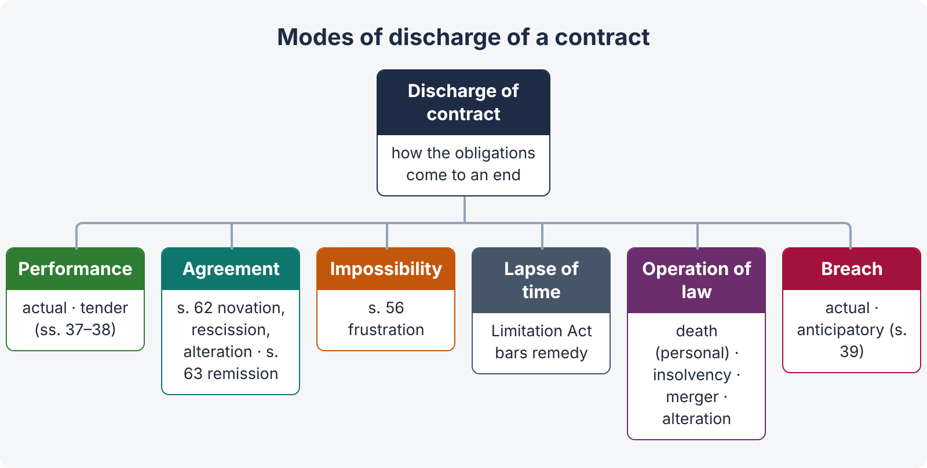
Figure 7 · Modes of discharge of a contract
- By performance — actual performance or a valid tender (ss. 37–38).
- By agreement — novation, rescission, alteration (s. 62); remission, extension, accord and satisfaction (s. 63); waiver; merger.
- By impossibility / frustration (s. 56).
- By lapse of time — the Limitation Act 1908 bars the remedy (the right survives — s. 25(3), s. 60).
- By operation of law — death in personal contracts (s. 37 illus. (b)); insolvency; merger of a lower right into a higher (e.g., a simple contract debt into a decree or a registered mortgage); unauthorised material alteration of a written contract.
- By breach — actual or anticipatory (s. 39) — which entitles the innocent party to treat the contract as discharged.
- By the promisee's neglect to afford reasonable facilities (s. 67).

10.2 Discharge by agreement — s. 62
"62. If the parties to a contract agree to substitute a new contract for it, or to rescind or alter it, the original contract need not be performed."
- Novation — a new contract replaces the old, either between the same parties on new terms (illus. (b): a mortgage for Rs. 5,000 in place of a debt of Rs. 10,000) or with a new party (illus. (a): A, B and C agree that C becomes B's debtor in place of A). Novation needs the consent of all parties; illus. (c): B tells A to credit C with Rs. 1,000, but C does not assent — no novation.
- Rescission — the parties cancel the contract by mutual agreement (without a new contract taking its place).
- Alteration — a change in one or more terms by agreement of all parties.
Requirements. The new agreement must be valid and made before the breach of the old contract (once a breach has occurred, the parties may still settle, but this is then an accord and satisfaction of the claim for damages). If the new contract is void or unenforceable, the old one revives (it was never discharged).

10.3 Remission and accord and satisfaction — s. 63
"63. Every promisee may dispense with or remit, wholly or in part, the performance of the promise made to him, or may extend the time for such performance, or may accept instead of it any satisfaction which he thinks fit."
Illustrations: (a) B forbids A to paint the picture — A is no longer bound; (b) A owes Rs. 5,000; B accepts Rs. 2,000 in satisfaction of the whole debt, paid at the time and place the Rs. 5,000 was payable — the whole debt is discharged; (c) C pays B Rs. 1,000 in satisfaction of A's debt of Rs. 5,000 — whole claim discharged; (d) an unascertained sum settled by Rs. 2,000 — discharged; (e) a composition with creditors of eight annas in the rupee — discharge.
COMMON MISTAKE · Section 63 differs from the English rule in Pinnel's Case and Foakes v. Beer
In England, payment of a smaller sum cannot discharge a larger debt already due, because there is no consideration for the creditor's promise to forgo the balance (Pinnel's Case (1602); Foakes v. Beer (1884) 9 App Cas 605) — unless something new is added (a different place, earlier time, a chattel), or promissory estoppel applies (Central London Property Trust v. High Trees House [1947] KB 130). Under s. 63, no consideration is needed: the promisee may simply accept less in full satisfaction. But the acceptance must be voluntary — a receipt obtained by pressure (e.g., "accept this or get nothing" when the creditor is in distress) may be set aside, and an endorsement "received in full and final settlement" may be challenged if signed under coercion or protest.

Waiver — the intentional relinquishment of a known right; it may be express or implied from conduct (e.g., accepting late performance — s. 55). Promissory estoppel — a party who has promised not to enforce his strict rights, intending the other to act on it, and the other has acted on it, cannot go back on his promise where it would be inequitable. It is recognised in Pakistan, though it cannot be used against statute or to compel a public authority to act unlawfully.

10.4 Rescission of voidable contracts — ss. 64 and 66
"64. When a person at whose option a contract is voidable rescinds it, the other party thereto need not perform any promise therein contained in which he is promisor. The party rescinding a voidable contract shall, if he have received any benefit thereunder from another party to such contract, restore such benefit, so far as may be, to the person from whom it was received."
"66. The rescission of a voidable contract may be communicated or revoked in the same manner, and subject to the same rules, as apply to the communication or revocation of a proposal."
Loss of the right to rescind: (1) affirmation after knowing the facts; (2) delay (laches); (3) third-party rights acquired in good faith for value before rescission (Phillips v. Brooks); (4) where restitution is impossible (the parties cannot be restored to their original position). The Specific Relief Act (ss. 35–38) gives a court remedy of rescission.

10.5 Frustration and impossibility — s. 56
"56. An agreement to do an act impossible in itself is void. A contract to do an act which, after the contract is made, becomes impossible, or, by reason of some event which the promisor could not prevent, unlawful, becomes void when the act becomes impossible or unlawful. Where one person has promised to do something which he knew, or, with reasonable diligence, might have known, and which the promisee did not know to be impossible or unlawful, such promisor must make compensation to such promisee for any loss which such promisee sustains through the non-performance of the promise."
Illustrations: (a) discover treasure by magic — void (initial impossibility); (b) A and B contract to marry; A goes mad — void; (c) A, already married and forbidden by his personal law to practise polygamy, contracts to marry B — A must compensate B; (d) A contracts to take in cargo at a foreign port; A's Government declares war on that country — void when war is declared; (e) an actor is too ill on several occasions — the contract to act on those occasions becomes void.

Three paragraphs, three rules
- Initial impossibility (para 1) — impossible in itself when made — void ab initio.
- Supervening impossibility or illegality (para 2) — frustration — the contract becomes void when the event happens.
- Known impossibility (para 3) — the promisor who knew (or should have known) must compensate the ignorant promisee.

The doctrine of frustration
CASE STUDY · Taylor v. Caldwell ((1863) 3 B & S 826)
Facts. A music hall was hired for four concerts. Before the first concert, the hall was destroyed by fire, without fault of either party.
Held. Both parties were excused. Where performance depends on the continued existence of a particular thing, a condition is implied that the parties will be excused if the thing perishes without fault.

CASE STUDY · Krell v. Henry ([1903] 2 KB 740)
Facts. Henry hired Krell's flat in Pall Mall for two days to watch King Edward VII's coronation procession. The procession was cancelled because the King fell ill.
Held. The contract was frustrated. Its foundation — the procession — had disappeared, though the flat could still physically be used. (Contrast Herne Bay Steam Boat Co. v. Hutton [1903] 2 KB 683: hire of a boat to see a naval review and cruise round the fleet — not frustrated when the review was cancelled, because the cruise round the fleet could still take place; the review was not the sole foundation.)

CASE STUDY · Satyabrata Ghose v. Mugneeram Bangur & Co. (AIR 1954 SC 44)
Facts. A company sold plots of land and undertook to build roads and drains. During the Second World War part of the land was requisitioned by the Government. The company claimed the contract was frustrated.
Held.
- In the subcontinent, frustration is governed by s. 56, which is a positive rule of law; the court need not rely on the English theory of an "implied term".
- "Impossible" in s. 56 is not limited to physical or literal impossibility; it includes impracticability — where the performance becomes useless from the point of view of the object and purpose the parties had in view.
- On the facts, the requisition was temporary, the contract had no time limit for the work, and it did not go to the root. Not frustrated.

CASE STUDY · Davis Contractors Ltd. v. Fareham UDC ([1956] AC 696, House of Lords)
Facts. Contractors agreed to build 78 houses in 8 months for a fixed price. Due to labour shortages, the work took 22 months and cost much more.
Held. Not frustrated. Frustration occurs only when, without default of either party, the obligation has become incapable of being performed because the circumstances would make it radically different from what was undertaken: "It was not this that I promised to do." Mere hardship, inconvenience or increased cost is not enough. (Similarly, Tsakiroglou & Co. v. Noblee Thorl [1962] AC 93: closure of the Suez Canal, forcing a longer route round the Cape, did not frustrate a sale of groundnuts.)

Grounds of frustration
- Destruction of the subject-matter (Taylor v. Caldwell).
- Death or incapacity in contracts of personal service (illus. (b), (e)).
- Change of law or government action making performance unlawful or impossible — requisition, prohibition of export or import, ban on a business.
- Outbreak of war (illus. (d)).
- Non-occurrence of an event which was the foundation of the contract (Krell v. Henry).
- Radical change of circumstances that makes performance useless for the agreed object (Satyabrata Ghose).

Not frustration
- Difficulty, hardship or increased cost of performance (Davis Contractors; Tsakiroglou).
- Commercial impossibility — the deal has become unprofitable.
- Strikes, lockouts, civil disturbances that only delay performance (unless they go to the root).
- Failure of one object where there are several objects (Herne Bay).
- Self-induced frustration — where the impossibility results from the party's own act or choice (Maritime National Fish Ltd. v. Ocean Trawlers Ltd. [1935] AC 524 — the company chose to allocate its limited fishing licences to other boats).
- Events which the parties foresaw and provided for in the contract (e.g., a force majeure clause) — such cases are governed by the contract (and s. 32 as a contingent contract), not s. 56.

Effect of frustration
- The contract becomes void from the time of the frustrating event — both parties are discharged from further performance (s. 56, para 2).
- Any party who has received an advantage must restore it or make compensation (s. 65; illus. (d) to s. 65: a singer too ill to sing must refund the advance, but need not compensate for lost profits).
- Para 3 compensation where the promisor knew of the impossibility.
ILLUSTRATION · COVID-19 and lockdowns
A wedding hall in Islamabad booked for 15 April 2020 could not hold the event because of the government's lockdown order banning gatherings. Performance became unlawful by an event neither party could prevent — the contract became void (s. 56, para 2); the hall must refund the advance (s. 65), less any agreed and reasonable costs if the contract so provided. If the contract had a force majeure clause dealing with "epidemic or government order", that clause would govern (the contract would be applied under s. 32 as a contingent contract).

Point | Frustration (s. 56) | Force majeure clause
Source | Law (statute) | Contract (agreement of parties)
Events | Unforeseen events that make performance impossible or radically different | Whatever events the clause lists (may include hardship)
Effect | Contract automatically void; discharge | As agreed — suspension, extension, termination
Court's role | Decides whether the foundation has gone | Interprets the clause

10.6 Restitution after a void agreement — s. 65
"65. When an agreement is discovered to be void, or when a contract becomes void, any person who has received any advantage under such agreement or contract is bound to restore it, or to make compensation for it, to the person from whom he received it."
Illustrations: (a) A pays B Rs. 1,000 for B's promise to marry C, A's daughter; C is dead at the time — the agreement is void; B must repay Rs. 1,000; (b) A was to deliver 250 maunds of rice by 1 May but delivered 130; B retains them — B must pay for 130; (c) a singer who sang five nights before the manager rescinded — the manager must pay for those five nights; (d) a singer too ill — must refund the advance.
When s. 65 does not apply:
- To an agreement void because of incapacity of a party (Mohori Bibee — minor).
- Where the parties knew from the start that the agreement was illegal — the in pari delicto rule prevails (the agreement was not "discovered" to be void).

10.7 Promisee's neglect to give facilities — s. 67
"67. If any promisee neglects or refuses to afford the promisor reasonable facilities for the performance of his promise, the promisor is excused by such neglect or refusal as to any non-performance caused thereby."
Illustration: A contracts to repair B's house; B refuses to point out the places needing repair — A is excused.
QUICK RECAP · Chapter 10 in eight lines
- Discharge by performance, agreement, impossibility, lapse of time, operation of law, breach, promisee's neglect.
- s. 62: novation (new contract; new party needs all to consent), rescission, alteration.
- s. 63: remit, extend time, accept any satisfaction — no consideration needed (contrast Pinnel, Foakes v. Beer); acceptance must be voluntary.
- ss. 64, 66: rescinding party restores benefits; rescission communicated like a proposal; right lost by affirmation, delay, third-party rights, impossibility of restitution.
- s. 56: initial impossibility void; supervening impossibility / illegality — frustration (Taylor v. Caldwell; Krell v. Henry; Satyabrata Ghose — impracticability, s. 56 exhaustive); known impossibility — compensation.
- Not frustration: hardship, cost (Davis Contractors; Tsakiroglou), self-induced (Maritime National Fish), foreseen events (force majeure clause, s. 32).
- s. 65: restore advantages when an agreement is discovered void or a contract becomes void — not for minors or knowingly illegal agreements.
- s. 67: promisee's refusal of facilities excuses the promisor.

Chapter 11 · Quasi-contracts — relations resembling contract (ss. 68 to 72)

11.1 The idea
Chapter V of the Act is titled "Of certain relations resembling those created by contract". These are obligations which the law imposes — without any agreement — to prevent a person from being unjustly enriched at another's expense. They are called quasi-contracts (or restitution).
LEGAL MAXIM · Nemo debet locupletari ex aliena jactura — no one should be enriched at another's loss
"…the gist of the action is that the defendant, upon the circumstances of the case, is obliged by the ties of natural justice and equity to refund the money" — Lord Mansfield in Moses v. Macferlan (1760) 2 Burr 1005. This is the root of quasi-contract.

Features:
- There is no agreement; the obligation is imposed by law.
- The right is usually to money (or restoration of a thing).
- The right is in personam — against a particular person.
- The person liable is treated as if he had contracted: compensation for failure to discharge such an obligation is the same as for breach of contract (s. 73, para 3).

11.2 The five cases
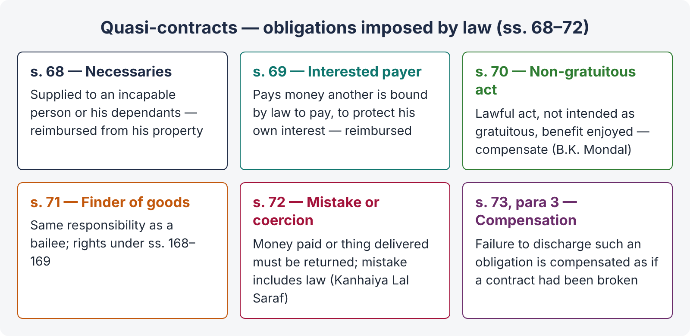
Figure 8 · Quasi-contracts — sections 68 to 72

Case 1 — Necessaries supplied to an incapable person (s. 68)
Covered in Chapter 4: reimbursement from the property of a minor or person of unsound mind (or of their dependants), for necessaries suited to their condition in life.

Case 2 — Payment by an interested person (s. 69)
"69. A person who is interested in the payment of money which another is bound by law to pay, and who therefore pays it, is entitled to be reimbursed by the other."
Illustration: B holds land in Sind on a lease from A, the zamindar. A's land revenue is in arrears and the land is advertised for sale, which would annul B's lease. B pays the revenue to save his lease. A must make good the amount to B.
Ingredients: (1) the payer is interested in the payment (to protect his own interest — not a mere volunteer); (2) the other person is bound by law to pay; (3) the payer is not himself bound to pay; (4) he pays to protect his interest.

Case 3 — Benefit of a non-gratuitous act (s. 70)
"70. Where a person lawfully does anything for another person, or delivers anything to him, not intending to do so gratuitously, and such other person enjoys the benefit thereof, the latter is bound to make compensation to the former in respect of, or to restore, the thing so done or delivered."
Illustrations: (a) a tradesman leaves goods at B's house by mistake; B treats them as his own — he must pay; (b) A saves B's property from fire — no compensation if A intended to act gratuitously.
Ingredients:
- The act is done lawfully;
- it is done not intending to act gratuitously;
- the other person enjoys the benefit — he had the option to accept or reject, and accepted it.
CASE STUDY · State of West Bengal v. B.K. Mondal & Sons (AIR 1962 SC 779)
Facts. A contractor built a kitchen, sheds and other structures for the Government at the request of an officer. The contract did not comply with s. 175(3) of the Government of India Act 1935 (contracts with Government must be in a prescribed form), so it was not a valid contract. The Government used the structures but refused to pay.
Held. The Government was liable under s. 70. The work was done lawfully, not gratuitously, and the Government accepted and enjoyed the benefit. Section 70 does not enforce the void contract; it imposes a separate obligation to pay for the benefit received.

This principle is often used in Pakistan for public works: when a contractor does additional work at the request of officials, and the department uses it, s. 70 allows a claim for reasonable value (quantum meruit), even if the formal contract or approval was lacking — subject to the requirement that the act was lawful.

Case 4 — Finder of goods (s. 71)
"71. A person who finds goods belonging to another and takes them into his custody, is subject to the same responsibility as a bailee."
So the finder must take reasonable care (s. 151), must not use them for himself, and must return them to the owner when found. In turn, he has rights: to retain the goods until compensated for his trouble and expenses (s. 168), to sue for a reward offered (s. 168), and in some cases to sell them (s. 169 — perishable goods, or lawful charges reaching two-thirds of value). (Bailment is in Topic 4.)

Case 5 — Money paid or thing delivered by mistake or under coercion (s. 72)
"72. A person to whom money has been paid or anything delivered by mistake or under coercion, must repay or return it."
Illustrations: (a) A and B jointly owe C Rs. 100; A pays; B, unaware, pays again — C must repay B; (b) a railway refuses to deliver goods except on payment of an illegal charge; the consignee pays to get his goods — he can recover the excess.
"Mistake" includes mistake of law.
CASE STUDY · Sales Tax Officer v. Kanhaiya Lal Mukundlal Saraf (AIR 1959 SC 135)
Facts. A firm paid sales tax on forward contracts, believing it was due. Later the levy was held invalid. The firm claimed a refund.
Held. The word "mistake" in s. 72 is used without qualification and includes a mistake of law as well as fact. The tax was refundable. (Section 21 — no relief for mistake of Pakistani law — applies to the validity of contracts, not to recovery of money under s. 72.)

"Coercion" in s. 72 has been read in a wider, general sense — not only the technical meaning in s. 15 — to cover payments made under pressure of an illegal demand (illus. (b)), e.g., an unlawful tax or fee paid under protest to avoid penalties.
Limits: a refund may be refused where the payer has passed on the burden to others (the doctrine of unjust enrichment applies both ways); and for relief on the ground of mistake, limitation is three years from when the mistake becomes known to the plaintiff (Art. 96, Limitation Act).

11.3 Quantum meruit — "as much as he has earned"
A claim for reasonable remuneration for work done, where there is no enforceable claim under the contract for the agreed price. It arises:
- where a contract is discovered to be void or becomes void (ss. 65, 70);
- where one party prevents the other from completing (s. 53) — the other may claim for work done;
- where work is done and accepted without a fixed price (s. 70);
- where a divisible contract is partly performed and the benefit accepted (s. 65, illus. (b), (c)).
CASE STUDY · Planché v. Colburn ((1831) 8 Bing 14)
Facts. The plaintiff agreed to write a book for a series "The Juvenile Library" for £100. After he had done much of the work, the publishers abandoned the series.
Held. He could recover £50 on a quantum meruit for the work done, as the defendants had prevented him from completing.

Not available to a party who himself is in breach of an entire contract (a "lump sum" contract), unless the other party has accepted the partial performance voluntarily (Sumpter v. Hedges [1898] 1 QB 673 — builder abandoned work; the owner completed it himself; no quantum meruit for the builder's work, since the owner had no real choice about "accepting" it).
CASE STUDY · Fibrosa Spolka Akcyjna v. Fairbairn Lawson Combe Barbour Ltd. ([1943] AC 32, House of Lords)
Facts. A Polish company paid £1,000 in advance for machinery. The contract was frustrated by the German occupation of Gdynia in 1939.
Held. Because there was a total failure of consideration, the buyer could recover the £1,000 paid in advance. (In Pakistan, s. 65 gives this result directly.)

Point | Contract | Quasi-contract
Basis | Agreement of parties | Imposed by law (equity / unjust enrichment)
Consent | Essential | Not needed
Right | Usually in personam, flows from promise | In personam, to money or restoration
Compensation | s. 73, para 1 | s. 73, para 3 — same as if a contract had been broken
Examples | Sale, loan, lease | Necessaries (s. 68), interested payer (s. 69), non-gratuitous act (s. 70), finder (s. 71), mistake / coercion (s. 72)

QUICK RECAP · Chapter 11 in five lines
- Obligation imposed by law to prevent unjust enrichment (Moses v. Macferlan); compensated as if a contract (s. 73 para 3).
- s. 68 necessaries — from property; s. 69 interested payer — reimbursement (lease-in-Sind illustration).
- s. 70 lawful, non-gratuitous act, benefit enjoyed — compensation (B.K. Mondal); s. 71 finder = bailee.
- s. 72 mistake (including law — Kanhaiya Lal Saraf) or coercion (wide sense) — repay.
- Quantum meruit (Planché v. Colburn; not for party in breach of entire contract — Sumpter v. Hedges); total failure of consideration (Fibrosa; s. 65).

Chapter 12 · Breach of contract and remedies (ss. 73 to 75)

12.1 Kinds of breach
- Actual breach — failure to perform on the due date, or defective performance.
- Anticipatory breach — refusal or disablement before the due date (s. 39; Hochster).
Remedies available to the innocent party:
Remedy | Law
Rescission — treat the contract as ended, and refuse further performance | ss. 39, 64, 75; Specific Relief Act ss. 35–38
Damages / compensation | ss. 73–75
Specific performance — order to perform the contract | Specific Relief Act 1877, ss. 12–30 (where damages are not adequate — e.g., immovable property, unique goods)
Injunction — prohibitory or mandatory, including to enforce a negative covenant | SRA ss. 52–57; O. XXXIX CPC
Quantum meruit | ss. 65, 70
Restitution of money paid | ss. 64, 65, 72

LEGAL MAXIM · Ubi jus ibi remedium — where there is a right, there is a remedy
The law gives the innocent party a remedy for every breach — at least nominal damages, even where no loss is proved.

12.2 Compensation for breach — s. 73
"73. When a contract has been broken, the party who suffers by such breach is entitled to receive, from the party who has broken the contract, compensation for any loss or damage caused to him thereby, which naturally arose in the usual course of things from such breach, or which the parties knew, when they made the contract, to be likely to result from the breach of it. Such compensation is not to be given for any remote and indirect loss or damage sustained by reason of the breach. [Para 3 — quasi-contracts, as above.] Explanation.— In estimating the loss or damage arising from a breach of contract, the means which existed of remedying the inconvenience caused by the non-performance of the contract must be taken into account."

The rule in Hadley v. Baxendale
CASE STUDY · Hadley v. Baxendale ((1854) 9 Exch 341)
Facts. The plaintiffs' mill stopped because its crankshaft broke. They gave it to the defendants, carriers, to take to engineers as a pattern for a new one. The carriers delayed delivery. The mill stayed idle for longer, and the plaintiffs claimed lost profits. The carriers were not told that the mill could not work without the shaft.
Held. The lost profits could not be recovered. Damages are recoverable only for loss that:
- arises naturally, according to the usual course of things, from the breach (first limb — general damages); or
- may reasonably be supposed to have been in the contemplation of both parties, at the time they made the contract, as the probable result of the breach (second limb — special damages, based on special knowledge communicated).
A mill-owner might well have a spare shaft; so the stoppage was not a natural consequence, and the special circumstance had not been communicated.

Section 73 is the statutory form of Hadley v. Baxendale. The two limbs correspond exactly to "naturally arose in the usual course of things" and "the parties knew, when they made the contract, to be likely to result".
CASE STUDY · Victoria Laundry (Windsor) Ltd. v. Newman Industries Ltd. ([1949] 2 KB 528)
Facts. A boiler for a laundry business was delivered five months late. The laundry claimed (a) the ordinary profits it would have earned and (b) the exceptional profits from lucrative dyeing contracts with the Ministry of Supply.
Held. The ordinary profits were recoverable — the sellers, being engineers, knew a laundry needed the boiler for immediate use. The exceptional profits from the Government contracts were not, as the sellers did not know of them. Recoverable loss is that which was reasonably foreseeable as liable to result, given the knowledge actually possessed.

CASE STUDY · Koufos v. C. Czarnikow Ltd. — The Heron II ([1969] 1 AC 350, House of Lords)
Held. In contract, the test of remoteness is narrower than in tort: the loss must have been in the reasonable contemplation of the parties as "not unlikely" to result (a "serious possibility" or "real danger"), not merely reasonably foreseeable. A shipowner who delayed delivery of sugar was liable for the fall in market price at the port, as he must have known sugar was likely to be sold on arrival.

The statutory illustrations — the best examples
Illus. | Point
(a) | Seller fails to deliver saltpetre — market price minus contract price at the date for delivery.
(b) | Ship does not come; the charterer gets other transport — trouble and expense recoverable.
(c) | Buyer says he will not accept the rice — contract price minus market price at the time of the refusal (anticipatory breach).
(d) | Buyer of a ship refuses — contract price minus resale price.
(e) | Late delivery of jute; price falls — difference between price at due time and at actual arrival.
(f) | Repairs not according to contract — cost of making them conform.
(i) | Carrier delays a machine knowing the mill is stopped — average profit of the mill during the delay, but not loss of a Government contract (unknown).
(j) | A tells C the purpose of buying iron (to perform A's contract with B) — C liable for A's lost profit on the B contract (special knowledge).
(k) | Late machinery — extra price for substitute recoverable; compensation to a third party (contract not communicated) — not recoverable.
(l) | Builder informed of B's lease to C — liable for rebuilding cost, lost rent and compensation to C.
(m) | Breach of warranty passed down a chain — the middle buyer recovers what he paid his sub-buyer.
(n) | Failure to pay money — only principal plus interest to the day of payment, not ruin of the creditor.
(o) | A sub-sale at a higher price is ignored; the market price on the due date governs.
(p) | Seller knows nothing of buyer's business; the mill closes — not liable for the closure.
(q) | Cloth for seasonal caps delivered late — market price difference only, not lost profits or preparation expenses (purpose not communicated).
(r) | Ship does not sail; passenger detained in Karachi — refund of deposit with interest, detention expenses, and excess fare; not the loss from arriving late in Sydney.

Kinds of damages
- Ordinary / general — natural consequence of the breach (first limb).
- Special — from special circumstances communicated at the time of contracting (second limb).
- Nominal — a token sum where a right is infringed but no real loss is proved (ubi jus ibi remedium).
- Exemplary / punitive — not ordinarily given in contract, because damages are compensatory, not to punish. Exceptions in English law: breach of promise to marry, and dishonour of a cheque by a banker with sufficient funds (injury to credit).
- Damages for mental distress — generally not awarded in contract (Addis v. Gramophone Co. [1909] AC 488), except where the very object of the contract was pleasure, relaxation or peace of mind (Jarvis v. Swans Tours [1973] QB 233 — a ruined holiday).

Principles of assessment
- Compensation, not punishment — put the innocent party, so far as money can, in the position he would have been in had the contract been performed (Robinson v. Harman (1848) 1 Exch 850).
- Market rule — in sale of goods, the difference between contract and market price at the time and place of the breach (illus. (a), (c); SGA ss. 56–57 — Topic 4).
- Duty to mitigate (Explanation to s. 73) — the innocent party must take reasonable steps to reduce his loss and cannot recover loss he could reasonably have avoided (British Westinghouse Electric v. Underground Electric Railways [1912] AC 673).
- Loss must be proved — the burden is on the claimant; damages must not be speculative, but difficulty of assessment is no reason to refuse damages (Chaplin v. Hicks [1911] 2 KB 786 — loss of a chance in a beauty contest compensated).
- Remoteness — indirect and remote losses excluded (s. 73, para 2).
- Expenditure wasted — the claimant may instead claim reliance expenses (wasted expenditure) in some cases (Anglia Television v. Reed [1972] 1 QB 60).
ILLUSTRATION · A local example of s. 73
Ali, a textile exporter in Faisalabad, orders a dyeing machine from Bilal Engineering for delivery by 1 March. He tells Bilal that he has an export order from a German buyer worth Rs. 20 million that he can fulfil only with the new machine. The machine arrives on 1 June; the order is lost. Bilal is liable for (i) the normal profits lost during the delay (first limb) and (ii) the lost profit on the German order, because that special circumstance was communicated at the time of contract (second limb; illus. (j), (l)). Ali must show he could not mitigate — e.g., by hiring another machine.

12.3 Penalty and liquidated damages — s. 74
"74. When a contract has been broken, if a sum is named in the contract as the amount to be paid in case of such breach, or if the contract contains any other stipulation by way of penalty, the party complaining of the breach is entitled, whether or not actual damage or loss is proved to have been caused thereby, to receive from the party who has broken the contract reasonable compensation not exceeding the amount so named or, as the case may be, the penalty stipulated for. Explanation.— A stipulation for increased interest from the date of default may be a stipulation by way of penalty. Exception.— When any person enters into any bail-bond, recognizance or other instrument of the same nature, or, under the provisions of any law, or under the orders of the Federal Government or of any Provincial Government, gives any bond for the performance of any public duty or act in which the public are interested, he shall be liable, upon breach of the condition of any such instrument, to pay the whole sum mentioned therein. Explanation.— A person who enters into a contract with Government does not necessarily thereby undertake any public duty, or promise to do an act in which the public are interested."

English law vs our s. 74
- In English law, a stipulated sum is either (i) liquidated damages — a genuine pre-estimate of loss, enforceable in full, or (ii) a penalty — a sum in terrorem (to frighten), unenforceable; only actual loss is recovered (Dunlop Pneumatic Tyre v. New Garage [1915] AC 79; now restated in Cavendish Square Holding v. Makdessi [2015] UKSC 67 — whether the clause protects a legitimate interest and is not out of all proportion).
- Under s. 74, this distinction is abolished for practical purposes. Whether the sum is called penalty or liquidated damages, the court awards reasonable compensation up to the named sum as a ceiling.
CASE STUDY · Fateh Chand v. Balkishan Dass (AIR 1963 SC 1405)
Facts. Under an agreement to sell a house in Delhi, the buyer paid Rs. 1,000 as earnest money and Rs. 24,000 towards the price, all to be forfeited on his default. The buyer defaulted; the seller forfeited the whole Rs. 25,000.
Held.
- Section 74 does away with the English distinction between penalty and liquidated damages; the court awards reasonable compensation not exceeding the sum named.
- The earnest money (Rs. 1,000) could be forfeited — it is a guarantee of performance.
- The Rs. 24,000 was part of the price, not earnest; its forfeiture was a stipulation by way of penalty. As the seller proved no loss, it had to be refunded.
- "Whether or not actual damage or loss is proved" means that the court may award reasonable compensation even where the exact loss cannot be proved — but the court must still be satisfied that some legal injury resulted.

CASE STUDY · Maula Bux v. Union of India (AIR 1970 SC 1955)
Held. Forfeiture of a reasonable sum paid as earnest money does not attract s. 74. But a security deposit for due performance is subject to s. 74; the Government could forfeit only reasonable compensation, and since it could have proved its loss and did not, it could not forfeit the deposit.

Pakistani illustrations (d)–(g) — Act VI of 1899
- (d) A bond for Rs. 1,000 at 12 %, with 75 % from the date of default — a penalty; only reasonable compensation.
- (e) A borrower to repay with 10 maunds of grain, or 20 maunds on default — a penalty.
- (f) A loan of Rs. 1,000 by five monthly instalments, with the whole becoming due on default — not a penalty (an acceleration clause merely brings forward what is already owed).
- (g) A borrowing of Rs. 100 with a bond for Rs. 200 by five yearly instalments of Rs. 40, whole due on default — a penalty (the bond amount itself is inflated).
The Exception — bail-bonds, recognizances and bonds for public duties — the whole sum is recoverable (illus. (c): recognizance of Rs. 500 forfeited — whole penalty payable). But under the second Explanation, an ordinary contract with Government (e.g., a supply or works contract) does not by itself involve a public duty.

Earnest money in Pakistani property deals
Earnest money (bayana) is the advance paid as a guarantee that the buyer will complete. If the buyer defaults, the seller may forfeit a reasonable earnest money; if the seller defaults, the buyer may claim its return — often with an agreed double amount. Pakistani courts generally apply Fateh Chand: a reasonable earnest may be forfeited, but forfeiture of a large part of the price is a penalty, and only reasonable compensation is allowed.

Interest and riba
Section 73 illus. (n) and s. 74 illus. (d) speak of interest. In Pakistan, interest (riba) is the subject of Article 38(f) of the Constitution (as amended by the 26th Amendment, 2024, setting 1 January 2028 as the target to eliminate riba) and of the Federal Shariat Court's judgment of April 2022, which declared laws permitting interest repugnant to the Injunctions of Islam with effect from a future date. Banking disputes are decided under the Financial Institutions (Recovery of Finances) Ordinance 2001, which speaks of "cost of funds". In an exam, you may note that "reasonable compensation" under s. 74 for delayed payment is today increasingly framed in these terms. Do not say that all interest is presently void under the Contract Act — the position is still evolving.

12.4 Compensation on rightful rescission — s. 75
"75. A person who rightly rescinds a contract is entitled to compensation for any damage which he has sustained through the non-fulfilment of the contract."
Illustration: the singer absent on the sixth night; B rescinds and may claim compensation (while paying for the five nights sung under s. 65, illus. (c)).
Point. Rescission and damages are not alternatives — a party who rightly rescinds does not lose his right to compensation (contrast the old view that rescission wipes out the contract entirely).
QUICK RECAP · Chapter 12 in eight lines
- Remedies: rescission, damages, specific performance, injunction, quantum meruit, restitution (ubi jus ibi remedium).
- s. 73 = Hadley v. Baxendale: natural loss + loss in contemplation from communicated special knowledge; no remote / indirect loss.
- Victoria Laundry (ordinary vs exceptional profits); The Heron II ("not unlikely").
- Use the illustrations (a)–(r): market rule, interest only for money (n), sub-sales ignored (o), special knowledge (j), (l).
- Compensatory not punitive; mental distress only for pleasure contracts (Jarvis); nominal damages; duty to mitigate (Explanation; British Westinghouse); loss of chance (Chaplin v. Hicks).
- s. 74: named sum = ceiling; reasonable compensation whether or not loss proved; penalty / liquidated distinction abolished (Fateh Chand); earnest money (Maula Bux).
- Pakistani illus. (d)–(g): penal interest and inflated bonds are penalties; acceleration of an actual loan is not. Exception: bail-bonds / public duty bonds — whole sum.
- s. 75: rightful rescission + compensation.

Chapter 13 · Terms of a contract — intention and relative importance
This chapter answers the KP High Court 2026 question on "the intention of the parties and the relative importance of contractual terms". It draws on the Contract Act (ss. 39, 55), the Sale of Goods Act 1930 (ss. 11–13 — Topic 4), and the common law.

13.1 Finding the intention of the parties
The court's task in interpreting a contract is to find the intention of the parties — but judged objectively: what a reasonable person, with the background knowledge available to the parties, would understand the words to mean — not what one party secretly intended.
LEGAL MAXIM · Verba chartarum fortius accipiuntur contra proferentem — words are construed most strongly against the party who put them forward
Where a term (especially an exclusion clause) is ambiguous, it is read against the party who drafted it and relies on it — the contra proferentem rule.

Rules of interpretation:
- Read the contract as a whole; give effect to every part if possible (ut res magis valeat quam pereat — it is better that a thing should have effect than be made void).
- Words in their ordinary meaning, technical words in their technical sense, in their commercial context.
- Specific words prevail over general; handwritten / typed additions over printed standard terms.
- Where there is ambiguity, look at the surrounding circumstances and the conduct of the parties.
- Oral evidence to vary a written contract is excluded, subject to exceptions — Arts. 102–103, Qanun-e-Shahadat 1984 (the "parol evidence" rule; formerly ss. 91–92, Evidence Act).

13.2 Express and implied terms
- Express terms — stated in words, orally or in writing.
- Implied terms —
  - implied in fact, to give business efficacy to the contract (The Moorcock (1889) 14 PD 64 — a wharf owner impliedly undertook that the river-bed at the jetty was safe for the ship to lie on at low tide), or terms so obvious that an "officious bystander" would say "of course!" (Shirlaw v. Southern Foundries [1939] 2 KB 206);
  - implied by law — e.g., the conditions and warranties implied in a sale of goods (SGA ss. 14–17: title, description, quality and fitness, sample);
  - implied by custom or trade usage, if reasonable, certain and notorious, and not inconsistent with the express terms.

13.3 Conditions, warranties and innominate terms
Not every term is of equal importance. The consequence of a breach depends on the class of term broken.
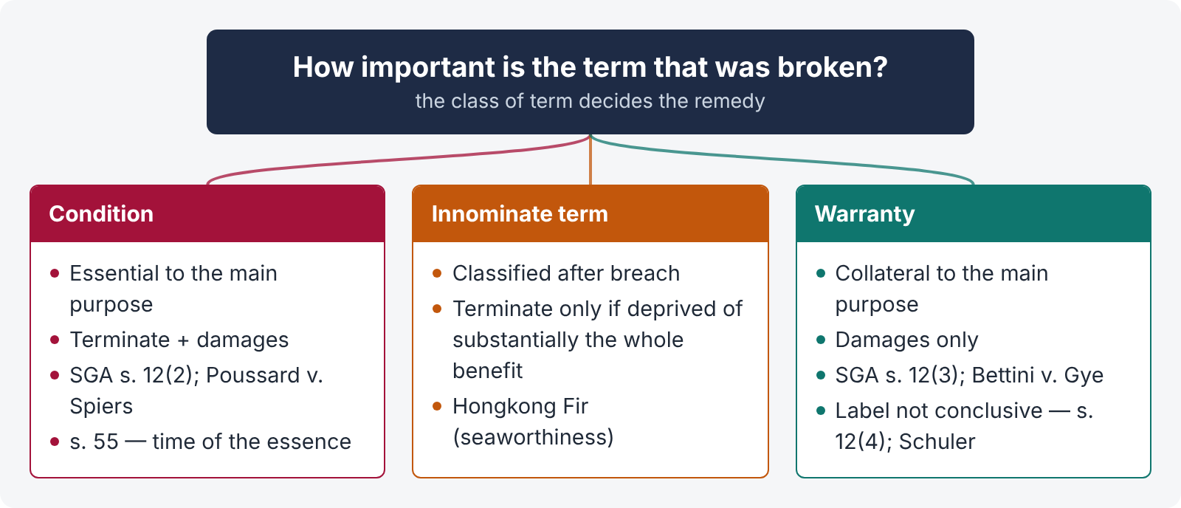
Figure 9 · Relative importance of contractual terms

Condition
A term essential to the main purpose of the contract. Breach gives the innocent party the right to treat the contract as repudiated (terminate) and claim damages. SGA s. 12(2): "A condition is a stipulation essential to the main purpose of the contract, the breach of which gives rise to a right to treat the contract as repudiated."

Warranty
A term collateral to the main purpose. Breach gives only a right to damages, not to terminate. SGA s. 12(3): "A warranty is a stipulation collateral to the main purpose of the contract, the breach of which gives rise to a claim for damages but not to a right to reject the goods and treat the contract as repudiated."
How to tell which is which — SGA s. 12(4): "Whether a stipulation in a contract of sale is a condition or a warranty depends in each case on the construction of the contract. A stipulation may be a condition, though called a warranty in the contract." The label used by the parties is not conclusive.
CASE STUDY · Poussard v. Spiers and Pond ((1876) 1 QBD 410)
Facts. An opera singer engaged for the leading role fell ill and could not appear for the first week, including the opening night. The producers engaged a substitute and refused her services when she recovered.
Held. Her failure to appear at the start went to the root of the contract — breach of a condition. The producers could terminate.

CASE STUDY · Bettini v. Gye ((1876) 1 QBD 183)
Facts. A singer engaged for a season was required to arrive six days before the first performance for rehearsals. He arrived only two days early. The employer refused to accept him.
Held. The rehearsal term was subsidiary — a warranty; its breach did not go to the root. The employer could claim damages but could not terminate.

Innominate (intermediate) terms
Some terms cannot be classified in advance; the effect of breach depends on the seriousness of its consequences.
CASE STUDY · Hongkong Fir Shipping Co. v. Kawasaki Kisen Kaisha ([1962] 2 QB 26)
Facts. A ship chartered for 24 months was to be "seaworthy". Because of an incompetent engine-room crew and old engines, it lost about 20 weeks to repairs. The charterers terminated.
Held. "Seaworthiness" is an innominate term — it can be broken in trivial or serious ways. The test is whether the breach deprived the innocent party of substantially the whole benefit intended. Here it did not (the charter still had a long time to run). The charterers were not entitled to terminate; they were liable for wrongful repudiation.

CASE STUDY · L. Schuler AG v. Wickman Machine Tool Sales Ltd. ([1974] AC 235, House of Lords)
Held. A clause calling the obligation to visit customers weekly a "condition" did not by that word alone make every minor breach a ground for termination. The more unreasonable the result, the more clearly the parties must have intended it. The label is strong evidence, but not conclusive.

CASE STUDY · The Mihalis Angelos ([1971] 1 QB 164)
Held. An "expected ready to load" clause in a charter-party is a condition: commercial certainty requires that the charterer can terminate if it is broken. In mercantile contracts, time clauses are usually conditions (Bunge Corp. v. Tradax Export [1981] 1 WLR 711).

Point | Condition | Warranty | Innominate term
Importance | Goes to the root | Collateral / subsidiary | Depends on the effect of breach
Right to terminate | Yes, for any breach | No | Only if the breach deprives the party of substantially the whole benefit
Damages | Yes | Yes | Yes
Classified | In advance by construction | In advance by construction | After breach, by looking at consequences
Authority | SGA s. 12(2); Poussard | SGA s. 12(3); Bettini | Hongkong Fir

Under the Contract Act
The Contract Act does not use the words "condition" and "warranty", but reaches similar results:
- s. 39 — a refusal or disablement to perform "in its entirety" allows termination; partial failure gives damages.
- s. 55 — failure to perform at the fixed time makes the contract voidable only if time was of the essence — i.e., if the time clause is in effect a condition; otherwise only compensation (like a warranty).
- s. 53 — prevention by the other party.

When a condition is treated as a warranty — SGA s. 13
The buyer may waive a condition, or elect to treat its breach as a breach of warranty; and where the buyer has accepted the goods (in a non-severable contract), a breach of condition can only be treated as a breach of warranty (SGA s. 13). (Topic 4.)

13.4 Exemption (exclusion) clauses — a short note
Standard-form contracts (bus tickets, laundry receipts, bank forms, insurance policies) often contain clauses excluding or limiting liability. Courts control them by:
- Incorporation — a clause binds only if it is part of the contract: a signed document binds even if unread (L'Estrange v. Graucob [1934] 2 KB 394), unless there was misrepresentation (Curtis v. Chemical Cleaning [1951] 1 KB 805); an unsigned ticket or notice binds only if reasonable notice was given before or at the time of contracting (Parker v. South Eastern Railway (1877) 2 CPD 416; Olley v. Marlborough Court Hotel [1949] 1 KB 532 — notice in the hotel room came too late).
- Construction — read contra proferentem; clear words are needed to exclude liability for negligence.
- Fundamental breach — whether a clause covers even a total failure of performance is a question of construction (Photo Production v. Securicor Transport [1980] AC 827).
- Statute and public policy — a clause contrary to s. 23 (e.g., excluding liability for fraud), or to a statute (e.g., the bailee's minimum duty of care under ss. 151–152, as held in Lily White v. R. Munuswami, AIR 1966 Mad 13 — a laundry's clause limiting liability to 50 % of the market price of lost goods was invalid), is not enforced. Consumer protection laws (e.g., the Islamabad Consumers Protection Act 1995) also protect consumers from unfair terms and defective services.
QUICK RECAP · Chapter 13 in six lines
- Intention is judged objectively; read the contract as a whole; contra proferentem; parol evidence rule (Arts. 102–103 QSO).
- Implied terms: business efficacy (The Moorcock), officious bystander (Shirlaw), by law (SGA ss. 14–17), by custom.
- Condition — essential, breach allows termination + damages (SGA s. 12(2); Poussard). Warranty — collateral, damages only (s. 12(3); Bettini). Label not conclusive (s. 12(4); Schuler).
- Innominate term — depends on seriousness of consequences (Hongkong Fir); mercantile time clauses are conditions (The Mihalis Angelos; Bunge v. Tradax).
- Contract Act analogues: s. 39 (refusal in entirety), s. 55 (time of essence), s. 53 (prevention); SGA s. 13 (condition treated as warranty).
- Exemption clauses: incorporation (L'Estrange; Parker; Olley), construction, fundamental breach (Photo Production), public policy and statute (Lily White).

Chapter 14 · Legal maxims for Topic 3 — at a glance
Maxim | Meaning | Where it applies
Pacta sunt servanda | Agreements must be kept | s. 37 — duty to perform
Consensus ad idem | Meeting of minds on the same thing in the same sense | s. 13; Raffles v. Wichelhaus
Ex nudo pacto non oritur actio | No action arises from a bare promise | s. 25 — agreement without consideration void
Quid pro quo | Something for something | s. 2(d) consideration
Ex turpi causa non oritur actio | No action arises from a base cause | s. 23 illegal agreements (Holman v. Johnson)
In pari delicto potior est conditio defendentis | Where both are equally at fault, the defendant is better placed | No recovery under illegal agreements; exceptions (Kiriri Cotton)
Caveat emptor | Let the buyer beware | s. 17 Explanation — mere silence is not fraud; SGA s. 16 — but see SGA s. 16A (Pakistani seller's duty to disclose defects)
Ignorantia juris non excusat | Ignorance of law is no excuse | s. 21 — mistake of Pakistani law
Ignorantia facti excusat | Ignorance of fact excuses | s. 20 — bilateral mistake of fact
Non est factum | It is not my deed | Mistake as to the nature of a signed document (Foster v. Mackinnon; Saunders)
Id certum est quod certum reddi potest | That is certain which can be made certain | s. 29 — uncertainty
Lex non cogit ad impossibilia | The law does not compel the impossible | s. 56 — impossibility and frustration
Impossibilium nulla obligatio est | There is no obligation to do the impossible | s. 56 para 1; s. 36
Nullus commodum capere potest de injuria sua propria | No one may profit from his own wrong | s. 53 prevention; self-induced frustration (Maritime National Fish)
Nemo debet locupletari ex aliena jactura | No one should be enriched at another's loss | ss. 68–72 quasi-contracts (Moses v. Macferlan)
Quantum meruit | As much as he has earned | ss. 65, 70; Planché v. Colburn
Ubi jus ibi remedium | Where there is a right there is a remedy | s. 73 — nominal damages at least
Restitutio in integrum | Restoration to the original position | s. 64 rescission; s. 65 restitution; s. 19A terms
Verba chartarum fortius accipiuntur contra proferentem | Words read against the party who put them forward | Interpretation of standard forms and exemption clauses
Ut res magis valeat quam pereat | Better that a thing should have effect than be void | Courts uphold commercial agreements; s. 29 illustrations
Uberrimae fidei | Of the utmost good faith | Insurance, family settlements — duty to disclose (s. 17)
Volenti non fit injuria | No injury to one who consents | Exemption clauses; acceptance of risk
Qui facit per alium facit per se | He who acts through another acts himself | s. 17 — fraud by an agent; agency (Topic 4)
Fraus omnia corrumpit | Fraud vitiates everything | s. 17, s. 19 — voidable; no protection to the fraudster under the s. 19 Exception

Chapter 15 · The great distinctions of Topic 3
Pair | First | Second
Agreement vs contract | Every promise or set of promises forming consideration for each other (s. 2(e)) | An agreement enforceable by law (s. 2(h)); every contract is an agreement, not vice versa
Void agreement vs voidable contract | Never enforceable; no rights for third parties | Valid until avoided; bona fide third-party rights protected (ss. 19, 19A, 55)
Void vs illegal | Merely unenforceable; collateral agreements valid (except wagers in Pakistan, s. 30A) | Forbidden; collateral agreements tainted; no restitution (in pari delicto)
Offer vs invitation to treat | Willingness to be bound on acceptance (s. 2(a)) | Invitation to make offers — displays, tenders, catalogues (Boots; Spencer v. Harding)
Counter-offer vs inquiry | Rejects and kills the offer (Hyde v. Wrench) | Seeks information; offer remains alive
Postal vs instantaneous acceptance | Proposer bound on posting (s. 4) | Complete when and where received / heard (Entores; Bhagwandas Kedia)
Consideration vs object | Price of the promise — what is given | Purpose of the agreement — what is sought
Privity of contract vs privity of consideration | Only parties may sue (followed in Pakistan, with exceptions) | Consideration may move from a third person — not required (s. 2(d); Chinnaya)
s. 25(3) vs s. 19 Limitation Act | New written, signed promise to pay a time-barred debt — new contract | Acknowledgment before expiry — fresh period for old debt
Coercion vs undue influence | PPC act / detention of property; by anyone; no relationship | Domination + unfair advantage; relationship essential; burden shift (s. 16(3))
Fraud vs misrepresentation | Knowing / reckless falsehood; damages in deceit | Honest but unwarranted belief; no damages; s. 19 Exception applies
Mistake of fact vs mistake of law | Bilateral and essential — void (s. 20) | Pakistani law — no relief; foreign law treated as fact (s. 21)
Bilateral vs unilateral mistake | Void (s. 20) | Not voidable (s. 22) — except identity, non est factum
Wager vs contingent contract | Mutual chances; no interest but the stake; void (s. 30) | Collateral uncertain event; valid (s. 31) — insurance
Wager vs insurance | No insurable interest; chance | Insurable interest; indemnity; utmost good faith
Frustration vs force majeure | By law (s. 56); contract becomes void | By contract; effect as agreed; governed by s. 32
Rescission (s. 62) vs rescission (s. 64) | By mutual agreement — discharge | By the party entitled to avoid a voidable contract — restores benefits
Novation vs alteration | New contract replaces old (may change parties) | Terms changed; same parties; same contract
Penalty vs liquidated damages | English law: penalty unenforceable; liquidated sum recoverable in full | Pakistani s. 74: no distinction — reasonable compensation up to the named sum (Fateh Chand)
Earnest money vs part-price | Guarantee of performance — reasonable sum forfeitable | Part of consideration — forfeiture is a penalty (Fateh Chand; Maula Bux)
General vs special damages | Arise naturally (first limb) | From communicated special circumstances (second limb) — Hadley v. Baxendale
Condition vs warranty | Essential; termination + damages (SGA s. 12(2)) | Collateral; damages only (SGA s. 12(3))
Contract vs quasi-contract | Created by agreement | Imposed by law to prevent unjust enrichment (ss. 68–72)
Restitution vs compensation | Return of a benefit received (ss. 64, 65, 72) | Making good a loss suffered (ss. 73–75)

Chapter 16 · Exam technique — contract problems

16.1 The five-step method for a contract problem
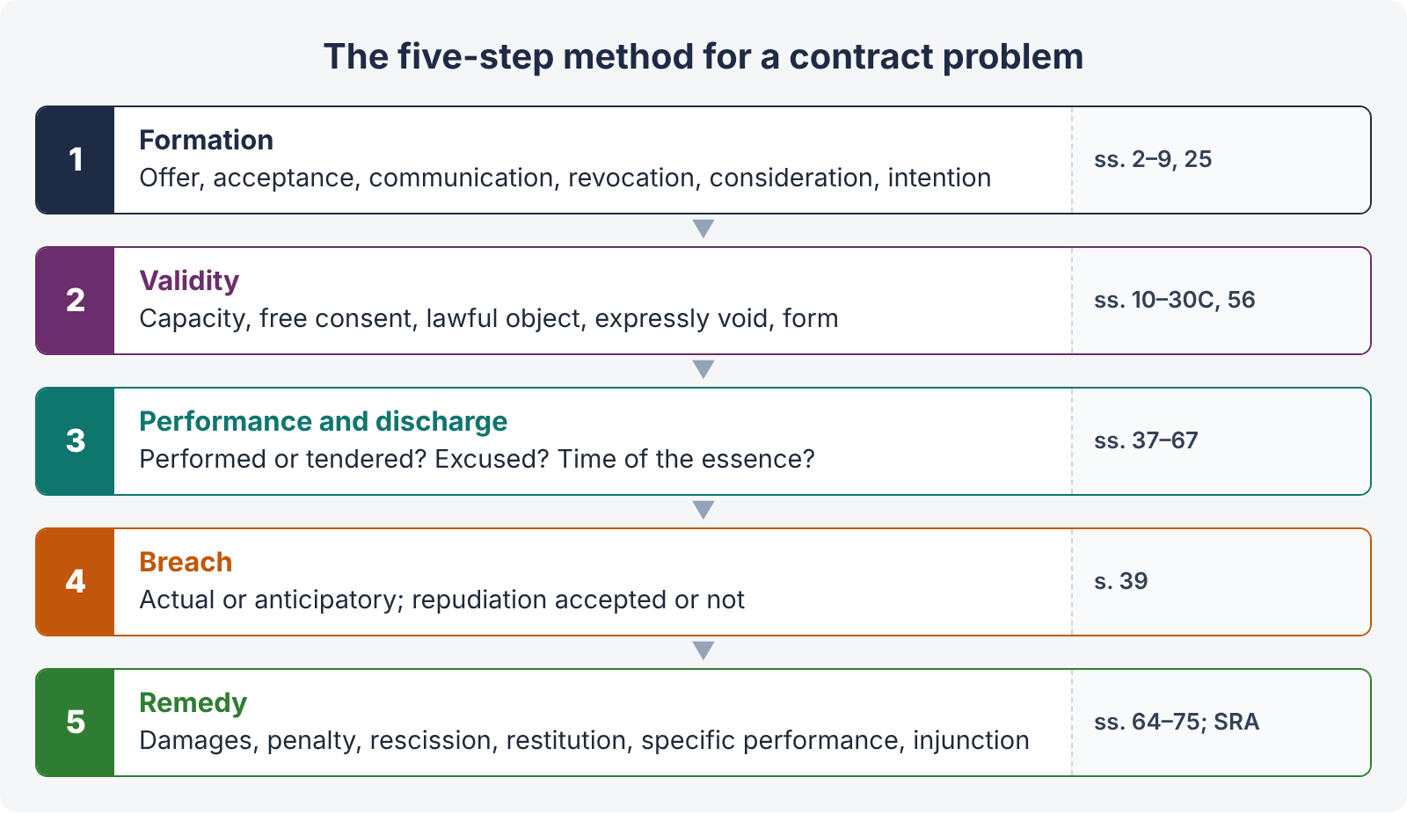
Figure 10 · The five-step method for a contract problem
- Formation — Was there an offer? Acceptance? Was it communicated (s. 4)? Was it revoked (ss. 5–6)? Consideration (s. 2(d), s. 25)? Intention to create legal relations?
- Validity — Capacity (ss. 11–12)? Free consent (ss. 14–22)? Lawful object (s. 23)? Expressly void (ss. 24–30A, 56)? Form (writing / registration / attestation — Art. 17 QSO)?
- Performance and discharge — Was it performed or tendered? Is the non-performance excused (s. 56, s. 63, s. 67)? Was time of the essence (s. 55)?
- Breach — Actual or anticipatory? Was the repudiation accepted (s. 39)?
- Remedy — Damages (s. 73: limbs, illustrations, mitigation); penalty (s. 74); rescission (ss. 64, 75); restitution (s. 65, s. 70); specific performance / injunction (SRA).

16.2 How to write the answer
- Open with a one-line statement of the issue: "The question raises the rules of acceptance by e-mail, counter-offer and revocation under ss. 2, 4–7 of the Contract Act 1872."
- Quote the decisive words of the section (you have the bare Act).
- Cite one case per point, with its ratio in a sentence.
- Use the statutory illustrations — they are often the exact answer.
- Apply the law to every fact given — examiners put each fact in for a reason.
- Show both sides where the law is unsettled (e.g., restitution against a minor; e-mail acceptance), and give your reasoned conclusion.
- Add the Pakistani touch — ss. 30A–30C, s. 74 illustrations (d)–(g), Art. 17 QSO, Electronic Transactions Ordinance 2002, procurement rules, the riba position.
- Conclude clearly: who wins, what relief, and why.

16.3 A 3-hour plan (reminder)
Ten minutes reading; about 33 minutes per 20-mark question; a quick answer map; quote the Act; one case per point; Pakistani features; clear conclusion; ten minutes for review.

Chapter 17 · Last-night revision sheet
QUICK RECAP · The 40 points of Topic 3
- Proposal + acceptance = promise; promise + consideration = agreement; enforceable agreement = contract (s. 2).
- s. 10: free consent, competent parties, lawful consideration and object, not expressly void; writing / registration only where another law requires (Art. 17 QSO; TPA; Registration Act).
- No contract without intention to create legal relations (Balfour v. Balfour).
- General offer accepted by performance (Carlill; s. 8); knowledge of offer needed (Lalman Shukla).
- Invitation to treat: displays (Boots), price quotes (Harvey v. Facey), tenders (Spencer v. Harding), auctions.
- Acceptance absolute and unqualified; counter-offer kills offer (Hyde v. Wrench); silence no acceptance (Felthouse); prescribed manner (s. 7).
- s. 4: acceptance binds proposer on posting, acceptor on receipt; instantaneous — where received (Entores; Bhagwandas Kedia).
- s. 5: revoke proposal before acceptance posted; revoke acceptance before it reaches proposer. s. 6: notice, lapse, condition, death / insanity known.
- Consideration at desire of promisor (Durga Prasad); from any person (Chinnaya); past valid; adequacy irrelevant except on free consent.
- Privity of contract followed, with exceptions (trust, family settlement, acknowledgment, agency, assignment).
- s. 25 exceptions: (1) written + registered + natural love and affection + near relation; (2) past voluntary service; (3) written, signed promise to pay time-barred debt; completed gifts.
- Charity subscriptions — enforceable only if acted upon (Kedarnath vs Abdul Aziz).
- Majority 18 (21 with court guardian) — Majority Act s. 3.
- Minor's agreement void ab initio; no refund under ss. 64–65 (Mohori Bibee); no ratification; no estoppel (Sadiq Ali Khan).
- Restitution of fraud-gained benefits (Khan Gul — Lahore FB) vs Ajudhia Prasad; minor can be promisee / agent / partner in benefits.
- s. 68 necessaries — from property only (Nash v. Inman).
- s. 12 sound mind: understanding + rational judgment at the time; lucid intervals; drunkenness.
- Consent = same thing in same sense (s. 13); free consent = "but for" causation (s. 14).
- Coercion: PPC act or unlawful detention of property, by / against anyone (s. 15; Chikham Amiraju; Ranganayakamma).
- Undue influence: domination + unfair advantage; burden shifts if unconscionable (s. 16; Raghunath Prasad); pardanashin (Farid-un-Nisa; Art. 127 QSO); guarantees (Bundy; Etridge).
- Fraud (s. 17; Derry v. Peek); silence not fraud unless duty to speak / equivalent to speech; misrepresentation (s. 18).
- s. 19: voidable or affirm; Exception for misrepresentation / fraudulent silence if discoverable with ordinary diligence; consent must be caused. s. 19A: set aside on terms.
- Mistake: bilateral essential fact — void (s. 20; Couturier; Bell v. Lever); Pakistani law — no relief (s. 21); unilateral — not voidable (s. 22), except identity (Cundy vs Phillips) and non est factum (Saunders).
- s. 23 heads: forbidden, defeats law, fraudulent, injury, immoral, public policy (Gherulal — unruly horse); illustrations (f), (h), (k).
- Ex turpi causa; in pari delicto; exceptions — not in pari delicto, locus poenitentiae. s. 24 partly unlawful — void; ss. 57–58 severable.
- s. 26 restraint of marriage of a major — void.
- s. 27: any restraint void (Madhub Chunder); goodwill exception; employment — during valid, after void (Golikari; Krishan Murgai).
- s. 28: absolute bar or shortened limitation void; arbitration and choice of competent forum valid (ABC Laminart).
- s. 29 uncertainty (oil illustrations).
- s. 30 wagers void (Hawkins J); horse-race prize Rs. 500+; ss. 30A–30C — collateral agreements void in Pakistan (contrast Gherulal).
- Contingent contracts (ss. 31–36): happen → wait; not happen → when impossible; fixed time; impossible event void.
- Perform or tender (ss. 37–38); refusal in entirety → terminate unless acquiesced (s. 39); anticipatory breach (Hochster; Avery v. Bowden).
- Joint promisors jointly and severally liable; contribution; release of one (ss. 42–44).
- Reciprocal promises (ss. 51–54); time of essence (s. 55) — not presumed in land sales (Chand Rani); readiness and willingness.
- Appropriation: debtor → creditor (even barred) → oldest first (ss. 59–61; Clayton's Case).
- s. 62 novation / rescission / alteration; s. 63 remission without consideration (contrast Foakes v. Beer).
- s. 56 frustration: impracticability (Satyabrata Ghose); Taylor v. Caldwell; Krell v. Henry; not hardship (Davis Contractors), not self-induced.
- s. 65 restore advantage; s. 70 non-gratuitous act (B.K. Mondal); s. 72 mistake incl. law (Kanhaiya Lal); quantum meruit (Planché).
- s. 73 = Hadley v. Baxendale; Victoria Laundry; mitigate; illustrations (a)–(r); no punitive damages.
- s. 74 reasonable compensation up to named sum (Fateh Chand); earnest money (Maula Bux); Pakistani illus. (d)–(g); bail-bond exception; s. 75 compensation on rescission. Conditions vs warranties vs innominate (Poussard; Bettini; Hongkong Fir).

